Ways to Prevent Ingrown Toenails, Part One
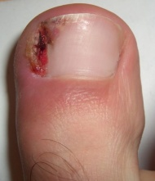
Hello friends! This is Doctor [first_name] [last_name] here again today to talk to you about ways that you can prevent ingrown toenails. Although not many people like to talk about it, I'm sure there are a number of you in [city] that are struggling with this painful condition. One of the most significant factors that causes people to develop an ingrown toenail is improper footwear. If your shoes are too tight and are pinching your toes, it may be causing your nails to curl. Shoes that chafe or restrict the foot day after day will eventually catch up with you in one form or the other, including the development of an ingrown toenail.
If you are suffering from this common condition, I can help! I encourage you to come see me, Doctor [last_name] at my office here in [city].
Ways to Prevent Ingrown Toenails, Part Two
This is Doctor [first_name] [last_name] with you again to give residents of [city] one more tip on how you can prevent the painful condition that is known as ingrown toenail. Ingrown toenails form when nails begin to grow into their bed, usually from the sides, and start to puncture the skin. Sometimes ingrown toenails develop as a result of trauma to the foot. For instance, if you stub your toe in the middle of the night as a result of your wife rearranging the furniture, or if your foot experiences shock during a sports activity, your toenail could react negatively by thickening or curling inward. If you fear that your nail may be progressing in that direction, seek help from a podiatrist right away. I would love for you to come see me, Doctor [last_name], here in [city].
What is a Bunion?
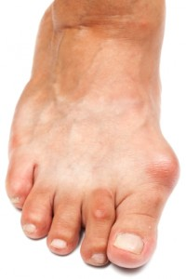
We all may have heard of bunions before and thought that they were simply afflictions that affect the elderly, but actually anyone of any age can develop this painful and embarrassing condition.
Hi, I'm Doctor [first_name] [last_name] and today, I want to educate the residents of [city] on this progressive disease. Bunions can be defined as the curving and protruding of the big toe, which stems from a number of factors including nerve problems, improper footwear and Rheumatoid Arthritis. The protruding is actually extra bone that begins to grow at the joint of the toe, which may become quite sensitive, red and inflamed.
If you think you might be suffering with a bunion, it's best to seek treatment right away. I invite you to come visit me, Doctor [last_name] here in [city] and let's take a look!
How to Tell if You Have Flatfoot
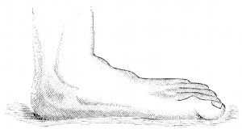
No, I didn't say Big Foot. Today we are talking about a condition called flatfoot that is found in many children, but can also develop in those of any age. Hello there, I'm Doctor [first_name] [last_name] and I have a podiatry office here in [city], where I spend my days helping people just like you recover from various ailments of the feet. Flatfoot can be identified quite easily. If your feet have lost their arch and seem to be completely flat, then alas, you have the condition. One way to tell is to wet your feet and step firmly on a dry surface so that your imprint is left behind. If there is no space missing for your arch, you in fact are flat-footed. The good news is that flatfoot is treatable, and you don't have to live with it for the rest of your life. I encourage you to come see me, Doctor [last_name], here in [city] and let's get you back on the road to recovery!
Morton’s Neuroma: What is it?
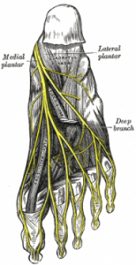
Morton's Neuroma is an agonizing disease. As a podiatrist, I can tell you that this condition is certainly nothing you want to ignore. Hi, my name is Doctor [first_name] [last_name] and I would like to teach my friends in [city] today about the interesting yet debilitating disease called Morton's Neuroma. Morton's Neuroma is a condition where the lateral plantar nerve joins with the the medial plantar nerve to form one large nerve between the third and fourth toes. When you walk and put pressure on this enlarged nerve, radiating pain is often felt throughout the foot, and some may feel as if they have a pebble in their shoe. At my office here in [city] we want to help those suffering with Morton's Neuroma and keep the problem from growing more severe. I invite you to come see me, Doctor [last_name], and let me bring you some much-needed relief!

Tips for Those with Ankle Sprains, Part One
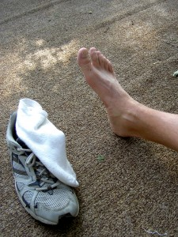
Many active and athletic individuals suffer with ankle sprains. It is important to treat this crippling condition promptly as there may be other underlying issues accompanying the sprain. This is Doctor [first_name] [last_name], and today I would like to share with those of you in [city] a podiatry tip in a three part series on ankle sprains. One of the most important keys to keep in mind is that those that suffer with ankle sprains should never soak their feet in hot water. Hot water actually increases the swelling as it increases the flow of blood to the area. The swelling will then cause added pressure on the nerves, which causes more pain.
If you're dealing with an ankle sprain, why not stop by my office in [city] and let me, Doctor [last_name] take a look!
Tips for Those with Ankle Sprains, Part Two
Ankle sprains are extremely common, but so are the mistakes that people make when treating a sprain. This is Doctor [first_name] [last_name]. Let's look at part two of my three-part podiatry series for residents of [city] about ankle sprains. If you suffer a sprain, never assume that an elastic bandage is sufficient for healing. While perhaps a bandage can help the ankle heal in some ways, it is vital not to overlook the fact that the affected ligament may have sustained a tear, or could be severely overstretched, thus warranting immediate medical attention. It is always necessary to see your podiatrist for a complete examination whenever you become injured by an ankle sprain. I encourage you to stop by my office in [city] anytime that we can be of help.
Tips for Those with Ankle Sprains, Part Three
Never make assumptions. That's today's tip in our three-part series on ankle sprains. Hi, I'm Doctor [first_name] [last_name], your local foot expert in [city]. Sometimes when people suffer an ankle sprain, they may think, "Well, it's just a sprain. It will heal on its own." BIG mistake! You may be dealing with hidden problems that warrant immediate attention and not even know it. What kind of problems? Well, chip fractures, toe fractures, or even a high ankle sprain, which is more serious than a regular sprain. The solution: Always see a podiatrist whenever you suffer an injury to the foot. I hope that you will choose me, Doctor [last_name] and my office here in [city].
What is Plantar Fasciitis?
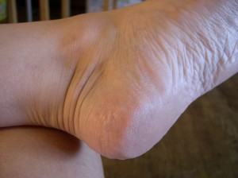
Not everyone speaks Latin, so it's understandable why the common layperson might not be familiar with a number of terms that I often use in my podiatry office, such as Plantar Fasciitis. Greetings; my name is Doctor [first_name] [last_name] and I help people every day in [city] with keeping their feet healthy and happy. The word "plantar" means "bottom of the foot," "fascia" means ligament, and "itis" means inflammation or infection. Therefore, an individual that suffers from Plantar Fasciitis has an inflamed ligament on the bottom of their foot. Plantar Fasciitis commonly makes itself known loud and clear at the end of the day after you have slowed down enough to rest your feet. You may also wake up in the morning and find your heels in excruciating pain.
If you're dealing with Plantar Fascitis, I want to help. I invite you to visit me, Doctor [last_name], at my office here in [city].
What Causes Plantar Fasciitis?
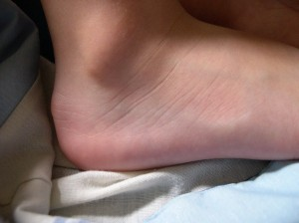
In my last post we learned a bit about the condition called Plantar Fasciitis and its definition. Today, I would like to outline some of the most common causes for this painful foot ailment. I'm Doctor [first_name] [last_name], and I have a podiatry office here in [city], where I help people just like you with the health of their feet. Plantar Fasciitis, also known as heel pain, is often caused by excessive pounding of the heels. Excessive pounding can stem from obesity issues, as the heels absorb all of our body weight when we walk. Those who have jobs that require individuals to spend most of the day on their feet are also at risk for the developing the condition.
If you've been putting a lot of stress on your feet and are suffering the painful consequences of it, I want to help. Visit me, Doctor [last_name] here in [city] and let's get you feeling better!

What is Neuropathy?
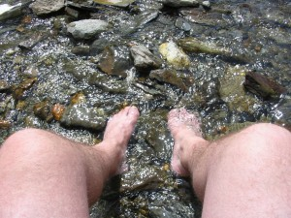
Neuropathy is an interesting foot ailment, since many can suffer from it and not even know it. I'm Doctor [first_name][last_name] and today's blog is about the condition called neuropathy, which I tackle as a podiatrist here in [city]. The word "neuro" stands for the body's nervous system. Your nervous system is what gives you the ability to feel and discern the difference between hot and cold, smooth and sharp. If the nerves become damaged in any way, the body -- in this case, the foot -- becomes numb. However, nerve damage can also result in shooting pains and muscle weakness that can be quite miserable.
If you think that you might have neuropathy, I invite you to visit me, Doctor [last_name], at my office here in [city].
What Causes Neuropathy?
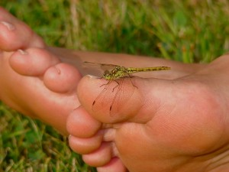
If you suffer with the condition called neuropathy, it is important to find the root cause of the problem. Good day; I'm Doctor [first_name] [last_name] and I operate a podiatry practice here in [city]. Today, I would like to teach you about some of the main instigators of neuropathy. There are a number of factors that can trigger this condition. Because smoking often depletes the body of much-needed oxygen, appendages such as legs and feet can lose their feeling. Alcohol can also have negative effects, as it is a toxin that can poison the nerves. Those with high blood sugar can commonly develop neuropathy as well.
If you think you might be suffering with this condition, I want to help. I encourage you to make an appointment to see me, Doctor [last_name], at my office in [city].

Get Your Life Back
I know that many foot ailments can be life-interrupting. I'm Doctor [first_name] [last_name], a podiatrist in [city]. Sometimes foot pain can be excruciating and keep you from doing the things that you would like. Sometimes unsightly afflictions can cause embarrassment to the point where you cover your feet as much as possible. I want to encourage you that there is hope for whatever condition you are dealing with. You don't have to keep suffering and living like a prisoner day after day.
I would love to help you get your life back. Why not make an appointment today to see me, Doctor [last_name], at my office in [city]?
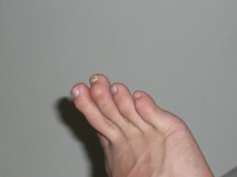
What Are Hammertoes?
Hammertoes are certainly an enigma. This progressive condition, however, is easy to identify. Hello friends; it's Doctor [first_name] [last_name], your favorite podiatrist here in [city]. I would like to talk to you today about hammertoes and how to know if you indeed have this foot ailment. Hammertoes most commonly develop on the second toe, but can also arise on the other digits as well. The condition can be characterized by a bending or curvature of the toe, which may become inflamed and be accompanied by a burning sensation. If not treated properly, the toe could freeze until it cannot move on its own. I know that hammertoes can be an embarrassing condition, and I want to help pull you out. I encourage you to come see me, Doctor [last_name], at my office here in [city].
Healing Hammertoes, Part One
While some people may try to use home remedies in order to avoid seeing a doctor, when it comes to hammertoes, it is important not to take chances with your feet. I'm Doctor [first_name] [last_name], a podiatrist here in [city], and I would like to share part one of a three part series on treatments that many try at home, but cannot completely heal hammertoes. Since improper footwear is one of the most common instigators of a hammertoe condition, some may think that simply purchasing new footwear will solve the problem. While comfortable shoes that allow your feet to breathe may help prevent further damage, they cannot repair the curvature that has already occurred.
You need to see a podiatrist like me, Doctor [last_name]. I invite you to come to my [city] office and get some real help and relief.
Healing Hammertoes, Part Two
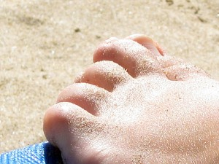
Hammertoes are no fun; but then again, what kind of foot ailment is? Thankfully, there is hope for healing hammertoes. I'm Doctor [first_name] [last_name], and today I would like to present part two of my three part series on some of the home remedies that many try to implement in their attempt to correct their hammertoes, but do not solve the problem. Sometimes individuals that suffer from hammertoes may place padding in their shoes under the ball of their foot or between their toes. While this may provide temporary relief from the intense pain resulting from a deformed toe, it has no bearing on the realignment of the toe itself.
It is important to see a podiatrist like me, Doctor [last_name], to proper and long-lasting treatment. I invite you to come to my office here in [city] so we can talk.
Healing Hammertoes, Part Three
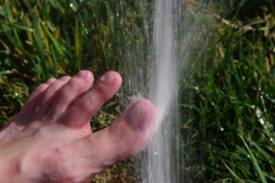
I'm Doctor [first_name] [last_name], and today we are going to wrap up our series on the foot condition called hammertoes. I hope that many of you in the [city] area have found this information to be helpful. Many times people try to treat their ailments, such as hammertoes, by using topical creams and lotions. While doing so may help to dissipate some of the redness and inflammation associated with the condition, it only helps to alleviate symptoms, while never addressing the root cause of the problem. It is important to sit down with a podiatrist and discover the root cause of your hammertoes. Why not come see me, Doctor [last_name], at my office here in [city] and we'll get you on the right path, so that you can truly experience healing for your hammertoes.

From Painful to Pampered
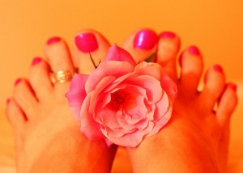
I know that you don't want your feet to hurt anymore. You're tired of the suffering, and you know that you need help. Well, you've come to the right place. I'm Doctor [last_name] and I am a local foot doctor here in [city]. I want to help relieve the pain and suffering that you are experiencing and make your feet happy and healthy again. Maybe you've even shed a few tears because of the intense ache that you feel after standing on your feet all day. Perhaps you've been longing to wear sandals, but have been afraid to because of the embarrassment you feel about how your feet look. You need to find relief right away. Wouldn't it be so nice just to go for a pedicure again? I can make it happen, but you need to come see me, Doctor [last_name]. I invite you to visit my podiatry office in [city] and take the first steps to freedom.
What Does Fungal Nail Look Like?
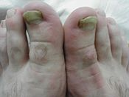
Fungal nail is not a pretty sight. If you have it, you know that there's a serious issue with your nail. Hello everyone, this is Doctor [first_name] [last_name] here today to give residents of [city] a few pointers in identifying the common condition called fungal nail.
Fungal nail appears in four variations:
1) The nail begins turning white or yellow and begins to detach from the bed at the sides.
2) A layer of foreign white material appears on the nail and persists on a daily basis.
3) The cuticles turn yellow, making the nail appear as if it is discolored at the root.
4) The entire nail plate turns yellow or green and becomes painful and swollen.
If you have fungal nail, I can help. I invite you to visit me, Doctor [last_name], at my podiatry office here in [city].

Podiatry Tips for Those with a Foot Fracture
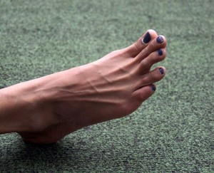
Foot fractures can be very painful. I know; I help people with the condition all the time. I'm Doctor [first_name] [last_name], and I am a podiatrist here in [city]. I would like to give you a few tips for proper treatment of a foot fracture. Foot fractures must be addressed as quickly as possible, preferably when the pain and swelling first begin. Not only can bones grow back together incorrectly, but foot fractures can turn into severe and chronic arthritis down the road if left untreated. Furthermore, putting repeated pressure on the fracture can result in a complete break. You need to get off of your feet as much as possible.
If you're looking for a foot doctor to help you with a suspected fracture, I'd love to assist you. Please feel free to stop by my podiatry office here in [city] and let's talk!
Risk Factors for Foot Fractures
I'm Doctor [first_name] [last_name], a podiatrist in [city], where we love making your feet happy. Today, I want to talk to you about some of the risk factors for foot fractures, which are more common than you might think. Foot fractures stem from shock and trauma to the bones in the feet. Athletes who repeatedly put stress on their feet, or who suddenly twist their feet during an activity are at risk for experiencing a fracture. However, the non-athletic among us are also at risk, as something as simple as a fall or dropping a heavy can on your foot from the kitchen cupboard can cause problems as well. Osteoporosis and age are two of the most significant factors, since the bones are more fragile and apt to break.
If you suspect that you might have a foot fracture, I invite you to come and see me, Doctor [last_name], at my podiatry office here in [city].

The Podiatrist’s War Against Foot Ulcers
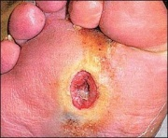
Foot ulcers. Ugh. I shudder just thinking about them. I'm Doctor [first_name] [last_name], and I'm a podiatrist here in [city]. I am on a mission to help my patients combat foot ulcers and eliminate them entirely. Foot ulcers are sneaky, especially since they start off small in the form of a blister or abrasion, and then develop into an open wound. The most common suffers of this condition are diabetics who struggle with neuropathy. This is a dangerous combination, because neuropathy hinders the body from sensing the normal pains of a wound, thus potentially leaving it undetected and open for further development and infection. If you suffer with foot ulcers, or are concerned about the potential for developing one, I want to help you conquer them head-on! Stop by and see me, Doctor [last_name], at my office in [city] and let's talk!

What is Diabetic Foot?
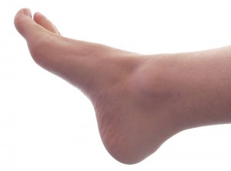
It is estimated that nearly 25% of individuals that have been diagnosed with diabetes experience complications with their feet. Hi, I'm Doctor [first_name] [last_name], and I have a podiatry practice here in [city]. I know how difficult it can be sometimes to fight the condition known as diabetic foot. I'm here to help. Diabetic foot is a condition where small cuts and bruises on the feet can become dangerous, due to the fact that many diabetics experience neuropathy, which keeps them from detecting injuries. Therefore, a simple blister can turn into a foot ulcer that eats away at the flesh if not dealt with promptly. While it is important for diabetics to regularly check their feet for any injuries, it is equally necessary to have regular check-ups at your local podiatrist's office. If you live in [city], please keep me, Doctor [last_name], in mind for your next appointment.

The Connection Between Weight and Flatfoot
Many people may not realize how much their weight affects their feet, but it is actually quite a significant factor in one's health and well-being. Good day, [city]! This is Doctor [first_name] [last_name] here to talk to you today about the connection between our weight and a condition called flatfoot. If you've been thinking about losing those extra pounds, let me give you a great reason to do so. Our weight put a lot of pressure on the main tendon that holds up the arch on our foot, and over time, that tendon can weaken if it continually put under stress. If the tendon gives way, then we lose our arch and thus become flatfooted. Because of this condition, weight is then applied to other parts of the foot, which causes severe pain and agony.
If you have flatfoot, please come see me, Doctor [last_name], for help at my office here in [city].
Steps to Eliminate Heel Pain, Part One
If you suffer with intense heel pain, you will be excited to read today's post. Hello friends, this is Doctor [first_name] [last_name], and I'm here today to give residents of [city] tips on eliminating heel pain. One of the ways to find relief from heel pain is to give your feet rest every day. If you work a job that keeps you on your feet all day, especially a position where you are continually pounding the pavement, your feet are going to naturally become tired and sore. At the end of the day, put your feet up and relax. Take some time to allow your heels to recover from the strain that they've been put through.
If you suffer with heel pain, I invite you to come visit me, Doctor [last_name], at my podiatry office here in [city].

Steps to Eliminate Heel Pain, Part Two
"Ow!" Is that the word of the day for you most of the time? If so, you need relief from your foot pain fast. I'm here to help. I'm Doctor [first_name] [last_name] and I am a foot doctor in [city]. Today, I would like to present part two of my three part series on ways that you can eliminate heel pain. Footwear is everything! If you are on your feet all day at work, are an avid runner, or are involved in other forms of athletics, it is important to choose footwear that provides sufficient cushioning for your feet. Your feet need the assistance of absorbing the shock of pounding the pavement. Just changing your shoes can help a lot. However, if you suffer with heel pain, you should also stay under the watchful eye of a licensed podiatrist. Why not come see me, Doctor [last_name] here in [city]?
Steps to Eliminate Heel Pain, Part Three
If you're ready to say goodbye to your heel pain, today is the day. This is Doctor [first_name] [last_name], and I am a podiatrist here in [city]. Let's take a look at part three of my series on steps to eliminating heel pain. If you engage in athletic activities, it is important to take a few minutes to warm up with simple stretches. Some athletes may be afflicted with heel pain due to the sudden shock that their ligaments experience. Gradually easing in to your workout could save you a lot of suffering.
If you find yourself struggling with persistent pain in your feet, come see me, Doctor [last_ name], at my office here in [city].
Pretty Feet
Do you long to have pretty feet again? Have you noticed others whose feet looked so pampered and perfect, while yours are cracked and aching? I'm Doctor [first_name] [last_name] and I can help. I run a podiatry office here in [city], where I specialize in helping people keep their feet healthy and beautiful. There's no need to be envious over others when help is within reach. I know that if your feet don't feel good, then YOU don't feel good. Your feet sometimes can be an indicator of other issues in the body, and so it is important to have a doctor take a look rather than letting things go and assuming that this is your destined lot in life. I invite you to visit my office here in [city] and let me put you on the pathway to healing.
Why a Podiatrist?
Maybe you've never visited a podiatrist before. Perhaps you've never seen a need to go to a foot and ankle doctor, and therefore, the topic has not been given much thought. That's okay. I'm here today to tell you why seeing a podiatrist may be just what the doctor ordered. My name is Doctor [first_name] [last_name], and I have a podiatry office here in [city]. I see lots of people all the time who have a plethora of problems with their feet: bunions, diabetic foot, flatfoot, ingrown toenails...you name it. Sometimes people put off going to the doctor because they feel that they can deal with issues on their own. However, home remedies fail while symptoms continue, and thus the pain sufferer knows that they must seek help from a professional. Perhaps you deal with sore feet at night. Maybe your toenails are discolored or cracked. Maybe you feel like your feet have lost their proper arch support. I would be happy to take a look at your feet and advise you regarding any underlying problems that you may not be aware of. You may be surprised about how much better you feel afterward. Why not visit me, Doctor [last_name], at my office here in [city]?
What are Dermophytes?
Hello friends in [city]! Doctor [first_name] [last_name] here. I would like to talk to you today about dermophytes. Without being a podiatrist like me, the regular layman is not familiar with the definition of a dermophyte. It's certainly not a word that one uses every day. However, at the same time, dermophytes might be trying to latch on your body each day without you knowing it! A dermophyte is a fungi that is a part of the mold and yeast family. People who suffer with excessive sweating, have improper footwear or socks that keep their feet moist are a target environment for dermophytes. If the fungi happens to attach itself to the nail, it does not let go very easily.The best thing that one can do who has been attacked by fungal issues is to visit a foot doctor like yours truly. I invite you to see me at my [city] office at your convenience.

Septicemia
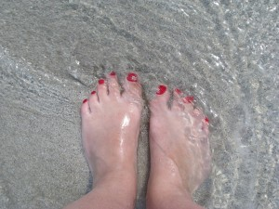
Did you know that certain foot issues, such as foot ulcers, can develop into an infection called septicemia if not treated? Hi, I'm Doctor [first_name] [last_name], and I am a podiatrist in [city]. I have people come to me all the time who say, "My foot hurts, but I'm not sure what to do!" Foot ulcers can be very serious. Septicemia is an even more serious condition which affects the blood stream. If a foot ulcer is not treated by a professional such as myself, even a seemingly minor open sore, the entire blood stream can become infected, causing you to feel very sick.
There's no need to let things progress this far. I invite you to come see me, Doctor [last_name], at my office in [city].
Embarrassed of your Feet?
Let's face it. There are a lot of people who are embarrassed of their feet. They don't want anyone to know about some of the unsightly ailments that they are struggling with. I'm Doctor [first_name] [last_name], a foot doctor from [city], and I'm here to tell you that you don't need to feel this way forever. I can help your feet look healthy and beautiful again. Issues such as discolored nails, fungal nails, hammertoes and morton's neuroma<em> can</em> be conquered. We help make it happen every day in my office. If you've been covering your feet up with heavy shoes, and have a hard time even looking at them yourself in the shower, I invite you to come to my office in [city] and let me, Doctor [last_name], help you out. You can count on me for compassionate care.
26 Bones
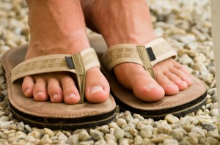
Did you know that there are 26 bones in your feet? Hi, I'm Doctor [first_name] [last_name], and I am a podiatrist in [city]. I would like to talk to you today about foot fractures. Since there are 26 bones in the feet, foot fractures can turn up in a number of locations: toes, arches, the shins, and more. Some people may be suffering with a foot fracture and not even know it. They may just be aware that their foot hurts and are not sure why.
If you are experiencing foot pain, let me help. Come see me at my office in [city] and let me see if perhaps you are dealing with a foot fracture that needs professional treatment.
Work-Related Foot Pain
Hi there. This is Doctor [first_name] [last_name], and I am a foot doctor in [city]. If you have a job that requires you to be on your feet all day, it's likely that you often experience foot fatigue or pain. There are a number of foot ailments that can occur as a result of repeated stress on your feet, from corns to blisters, to even more serious issues such as bunions and plantar warts.
As a podiatrist, I can prescribe a plan for you to avoid serious problems with your feet that can stem from your active professional life. Stop by my office in [city] to learn learn more.
What are Plantar Warts?
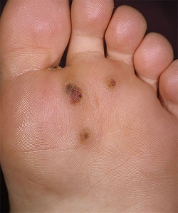
We all know about warts that can grow on the hand, but how many have heard of warts of the feet? Doctor [first_name] [last_name] here, and I would like to talk to residents of [city] who may be experiencing foot pain about a condition called plantar warts. Plantar warts are one of the most common foot ailments today. However, they are often mistaken for corns or calluses. The condition develops most often at either the heel or ball area of the foot, and first appears as a crusted lump. If it is left to progress, it bores deeper into the flesh and becomes extremely tender and sore.
If you think you may be dealing with plantar warts, I encourage you to make an appointment to see me, Doctor [last_name], at my office here in [city].

What Causes Plantar Warts?
Hello, this is Doctor [last_name], your favorite podiatrist in [city]. During our last session, we talked about plantar warts and how to identify them. Today, I want to tell you about what causes them. As surprising as it may seem, plantar warts are the result of the human papilloma virus, also known as HPV. HPV commonly grows in wet and warm areas, such as bathrooms and locker rooms and is contracted through cuts, abrasions and breaks in the skin. If you think that you might have developed plantar warts, it is important to see a foot doctor right away. I encourage you to see me, Doctor [last_name], at my office here in [city].

How Flatfoot Affects the Entire Body
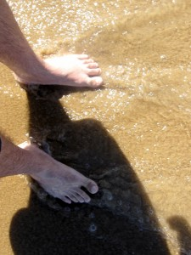
Hello, this is Doctor [first_name] [last_name] here, your local podiatrist from [city]. I would like to talk to you today about flatfoot and how it can affect the entire body. Most of us would assume that flatfoot only affects, well, the foot. Therefore, it may be surprising that it can affect other parts of the body. However, when an individual loses the support of their arch, weight is then shifted to other areas, such as the hips or knees. When the feet are not carrying a person properly, the rest of the lower body tries to make up for it. Consequently, the body feels a lot of pain because of the strain and misalignment.
If you are struggling with flatfoot, I encourage you to come see me, Doctor [last_name], at my office here in [city].
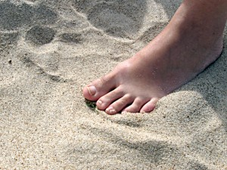
Don’t Operate Your Own Personal Treatment Center, Part One
Sometimes people try to treat their own foot pain, and play the role of both doctor and patient. Hi, I'm Doctor [first_name] [last_name], a podiatrist from [city], and I would like to talk to you today about some of the mistakes that people make by trying to treat their bunions by themselves. Many people use topical creams to help relieve their suffering; however, topical creams can never cure a bunion or any other foot ailment. They may bring temporary relief in helping to reduce redness or swelling, but the issue still remains.
It's best to allow a trained professional to look at your feet. I encourage you to come to my office here in [city] and let me help.
Don’t Operate Your Own Personal Treatment Center, Part Two
Good day, Doctor [first_name] [last_name] here, ready to talk to my friends in [city] again today about some of the mistakes that people make by trying to treat themselves. Specifically, we are focusing on the condition known as bunions, which affects many people today. Many times people try to treat their bunions by using an ice pack. While this may help to relieve some of the swelling that develops from the protruded bone, it will not target the root cause of the issue that is causing the swelling in the first place.
If you are dealing with a bunion, see a podiatrist right away. I'd love for you to visit me, Doctor [last_name], here at my office in [city].
Don’t Operate Your Own Personal Treatment Center, Part Three
Hi, I'm Doctor [first_name] [last_name], a foot doctor here in the [city] area, and today, I am going to conclude our three-part series on some of the mistakes the people make by trying to treat their own foot ailments, specifically the condition known as bunions. Although bunions can be quite painful, using pain killers to relieve your suffering is only a temporary fix. After a few hours, the medicine wears off and the pain returns. Pain killers, furthermore, can be addictive and some may have negative side effects. If you really want to fight the pain that is associated with bunions, make an appointment with a licensed podiatrist as soon as possible. In fact, why don't you come see me, Doctor [last_name], at my office here in [city]?

Why Sitting Cross-Legged Can Pose Problems for Those With Diabetic Foot
Hi, I'm Doctor [first_name] [last_name], and today I would like to speak to residents of [city] about why sitting cross-legged can pose problems for those with diabetic foot. Diabetic foot is a condition which must be carefully monitored. There are a number of factors that can have an adverse effect on circulation and cut off the blood supply to the feet. One of those factors is sitting cross-legged. Sitting in this manner can reduce the amount of blood in the feet that is needed to heal wounds or address underlying issues. It also can make your foot go numb, similar to the effects of neuropathy.
If you have diabetic foot, I want to help. I invite you to come see me, Doctor [last_name], at my office here in [city].
Suffering From an Ingrown Toenail?
Are you suffering from the pain of an ingrown toenail? Does your foot throb when you put pressure on it? Does the light weight of your bed sheets even cause pain at times? Hi, I'm Doctor [first_name] [last_name], a podiatrist here in [city], and I want to help. Although the toe is one of the smallest and most forgotten members of the body, when it is injured, it can quickly gain your attention. I understand that the pain can be debilitating at times, and many suffer unnecessarily because they try to treat themselves or wait for the problem to go away on its own.
I invite you to come to my office here in [city] and let me help stop the progression of your ingrown toenail in its tracks.
What is the Lateral Plantar Nerve?
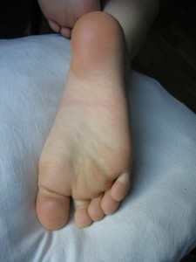
It's amazing to study all of the nerves, muscles, tissues and bones of the feet. Each one has an important role, and if afflicted, can cause lots of pain. I'm Doctor [first_name] [last_name], an orthopaedic specialist in [city], and I would like to talk to you today about the lateral plantar nerve. The lateral plantar nerve has both superficial and deep branches that stretch out across the foot. It is part of the tibial nerve, and affects the muscle called the flexor digiti minmi brevis, whose function is to flex the little toe. When the lateral plantar nerve combines with the medial plantar nerve, a painful condition develops called morton's neuroma. If you think you have morton's neuroma, or are experiencing other issues with foot pain, visit me, Doctor [last_name], at my office here in [city].
What is the Medial Plantar Nerve?
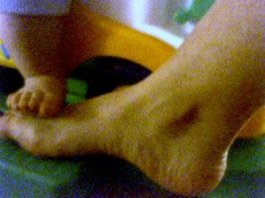
Most of us don't give thought to the nerves in our feet, at least until those nerves are pinched or are affected by other disorders. I'm Doctor [first_name] [last_name], a foot doctor in [city], and I would like to teach you today about a very important nerve in the foot called the medial plantar nerve. The main job of the medial plantar nerve is to support the longitudinal arch of the foot and also to flex the joint of the big toe. The name of the muscle that is directly affected by, or dependent on, the nerve is called the flexor hallucis bervis. When the medial plantar nerve connects to the lateral plantar nerve, a painful condition develops called morton's neuroma. If you are dealing with foot pain and suspect that it might be a nerve condition, come visit me, Doctor [last_name], at my podiatry office in [city].
What are the Functions of Foot Muscles?
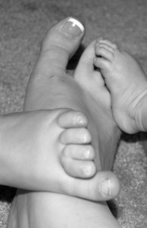
Hello, this is Doctor [first_name] [last_name], your favorite podiatrist in [city]. Today I would like to talk to you about foot muscles. Everyone knows why muscles of the arm are important, but not many people know why foot muscles are necessary. Muscles in the feet are of utmost importance to the body as they serve two functions: they allow your foot to bend and move, including your toes, and they provide support and structure for the arches, which help you to keep your proper balance. Sometimes repeated stress can cause injury to the muscles of the foot. If you've been experiencing foot pain, I invite you to visit my office in [city].

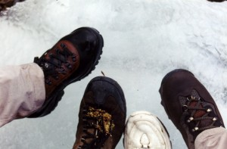
Neuropathy and Frostbite: A Dangerous Combination
I'm Doctor [first_name] [last_name], and today I would like to speak to residents of [city] who suffer from diabetes and neuropathy about why it's important to avoid frostbite. Neuropathy, a condition often experienced by those with diabetes, affects the body's ability to feel, and therefore, hot and cold often cannot be discerned. A person with neuropathy is more prone to obtain frostbite, since they cannot feel when frosty air is negatively affecting their skin. This puts the individual at risk for an amputation. If you are one of the many Americans that struggles with neuropathy, I invite you to visit me, Doctor [last_name], at my office here in [city].
Epsom Salt
Doctor [first_name] [last_name] here to talk to my friends in [city] about epsom salt, which is commonly used to relieve foot pain. Espsom salt does have good properties, including the ability to help draw toxins out of the body and to relieve everyday aches and pains. Some find it relaxing to soak their feet at the end of a long day in a solution of epsom salt and water. However, if one is needing relief from serious ailments such as bunions, morton's neuroma and hammertoes, epsom salt in itself is not sufficient. Sometimes it is just best to see a professional.
If your feet hurt, I invite you to come see me, Doctor [last name], at my office in [city].
Splaying Sports with an Ingrown Toenail
Hello, this is Doctor [first_name] [last_name] here to explain to my friends in [city] why it's problematic to engage in sporting activities with an ingrown toenail. Since ingrown toenails puncture the skin as they turn downward, playing sports such as kickball, soccer or football can cause further damage and shock to the toe if the ailment is not dealt with prior to engaging in the activity. It is important to seek professional assistance from a licensed podiatrist. If you have an ingrown toenail, I encourage you to visit me, Doctor [last_name], at my office here in [city].
You’re Not Under House Arrest
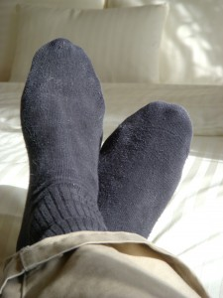
Foot and ankle pains can be debilitating. Some may be afraid to go to social functions out of fear that someone might see how their feet look or because of the intense agony. I'm Doctor [first_name] [last_name], a podiatrist in [city], and I would like to encourage you today to stop living like you're under house arrest. Being cooped up in the house is no way to live. Your pain need not hold you prisoner. Not when when so much help is available...now!
I encourage you to come see me at my [city] office, so that I can help you be free once and for all.

Symptoms of Flatfoot
This is Doctor [last_name], your favorite foot doctor from [city]. Some of my readers may have flatfoot and not even know it. Therefore, I would like to outline some of the most common symptoms of flatfoot. Flatfoot can make itself known in a number of ways. Some may experience pain and discomfort in their heel or arch area. Some may notice swelling inside their foot. Some may have shin splints. Others may have pain in their knees and lower back.
If you experience any of these symptoms, I invite you to visit me at my office here in [city].
The Progression of Plantar Warts
Many people each year are afflicted by plantar warts. I'm Doctor [first_name] [last_name], a podiatrist in [city]. I would like to talk to you today about plantar warts and how they progress if not dealt with at the onset. Plantar warts start off as a rough lump that develops on the bottom of the foot, which may also be accompanied by black dots. If the warts are not treated by a professional at the onset, the dots begin to turn brown and the lump bores deeper into the flesh, becoming a hard and painful spot.
If you have plantar warts or think that you do, I want to invite you to come to my office here in [city].
Never Assume
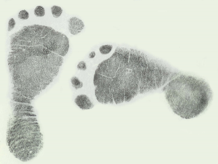
Assumptions can be very dangerous, especially when it comes to physical injuries. I'm Doctor [first_name] [last_name], a podiatrist in [city], and today I would like to talk to you about why you should never make assumptions about foot pain. X-rays are often necessary for those who have suffered an injury to the foot as there may be hidden issues that are not seen by the naked eye. The patient may be dealing with a chip fracture, a torn ligament or even a fracture in one of the small bones of the toe. If your foot hurts, don't take chances. See a podiatrist right away. I invite you to come to my office here in [city] to receive prompt, compassionate care.
Osteoporosis and Foot Fractures
I'm Doctor [first_name] [last_name], and I'm a foot doctor in [city]. I would like to talk to you today about the correlation between osteoporosis and foot fractures. Osteoporosis greatly increases an individual's chances of fracturing or breaking one of the 26 bones in their feet. Because bones are weaker, a fall or a sudden impact on the foot, such as a can falling out of the cupboard or kicking into furniture, can cause injuries more easily. If you have been diagnosed with osteoporosis, and are also experiencing foot pain, please see a podiatrist right away. I invite you to come to my office here in [city] and allow me, Doctor [last_name], to help diagnose the problem.

Inaction is not an Option
Some people live by the motto, "If I ignore it, maybe it will go away." However, such a notion can be dangerous when it comes to afflictions of the foot. I'm Doctor [first_name] [last_name], a podiatrist in [city], and I want to encourage you not to wait for your pains to heal themselves. A number of diseases of the foot can progress if left untreated. Foot ulcers can spread, hammertoes can curl even more permanently, and morton's neuroma can turn more severe until surgery is needed. Sometimes foot fractures that are untreated can lead to serious arthritic conditions. Inaction is never an option when it comes to ailments of the feet. It's important to seek professional help. I invite you to come see me, Doctor [last_name], at my office in [city].
Discolored Nails
This is Doctor [first_name] [last_name], a podiatrist in [city]. I would like to talk to you today about discolored nails. Some may think at the first sign of a discolored and thickened toenail that they have contracted fungal nail. While it could very well be the case, not every discolored toenail is fungal nail. There are a number of issues that you may be dealing with as bacteria takes a variety of forms. Your nails could be yellow, white, green or even black. To properly diagnose the underlying issues with your nails, see a professional foot doctor. I invite you to come to my office here in [city] so that I can take a look.
The Progression of Hammertoes
This is Doctor [first_name] [last_name], your favorite podiatrist in [city]. Today's post is about hammertoes and what can happen when they are left untreated. Hammertoes progress over time, and once they form, they become very obvious. The toes begin to curl in and look like a claw. If the condition is not addressed by a professional, the middle joint of the toes will eventually freeze until they cannot move on their own.
If you are suffering with hammertoes, I invite you to come to my office here in [city] and let me help you before things progress to this stage.
Pronation
Doctor [first_name] [last_name] here. I would like to talk to residents of [city] today about a condition called pronation. Pronation is when the side of the foot rolls inward when walking. It can be characterized as an abnormal leaning in of the foot that can cause stress on the ligaments. This stress then can result in painful conditions such as plantar fascitis, in which the ligament that connects the heel with the ball of the foot is torn and inflamed. If you are one of the many Americans that has pronation when they walk, I invite you to come see me, Doctor [last_name], at my office here in [city].

The Connection Between Alcohol and Neuropathy
I am Doctor [first_name] [last_name], a podiatrist in [city], and today I would like to talk to you about the connection between alcohol and neuropathy. Alcohol is known to be a toxin. This toxin can act like a poison to the nerves, affecting their ability to function, thus inhibiting their purpose of sensing good and bad feelings, including in one's feet. The feet may seem as if they have fallen asleep or are dull to the touch of heat or pressure. If you believe that you are suffering with neuropathy, it is important to see a podiatrist for help. I invite you to come to my office here in [city] and let me take a look.
Children and Podiatry
I'm Doctor [first_name] [last_name], the foot doctor of choice here in [city]. Today, I would like to talk to you about why children may sometimes need to see a podiatrist. One of the most common foot ailments in children is flatfoot. This is when the foot has lost its natural arch and looks to be completely flat. Because of this condition, weight may be applied to other parts of the foot, which may cause pain or skeletal structure issues. Thankfully, flatfoot is treatable. If you suspect that your precious little one has flatfoot, I invite you to bring him or her to my office here in [city].

Avoid Costly Mistakes
This is Doctor [first_name] [last_name], the podiatrist of choice in [city]. In these tough economic times, everyone wants to be frugal wherever possible. When it comes to foot pain, seeking professional assistance at the onset can help you to avoid costly mistakes. Some may think that they can't afford to go to a podiatrist. However, the truth is that they can't afford <em>not</em> to go to one. Putting off making an appointment and hoping that the problem will somehow go away by itself puts the sufferer at risk for serious progression, which will end up costing a lot more money than if the issue had been dealt with at the onset. If your foot hurts, or if you have wounds or discoloration of the nail, I invite you to see me, Doctor [last_name], at my office here in [city].
Podia-Trust
This is Doctor [first_name] [last_name], your friendly foot doctor from [city]. Today, I want to talk about the importance to finding a podiatrist that you can trust. When it comes to the health of your feet and the relief of pain, it's vital to choose doctors wisely. How long has the podiatrist been in practice? What kind of training does he or she have? What kind of reviews has the office obtained online? You want a doctor that you know is truly helping you along the road to recovery, and is not just taking your hard-earned money. I invite you to read my full report on some of the common mistakes that people make when choosing a podiatrist. Hopefully, after reading this report, you'll stop by and see me, Doctor [last_name], at my [city] office, where we'll build the patient-doctor trust with you that you've been looking for.

Excessive Sweating and Fungal Nail
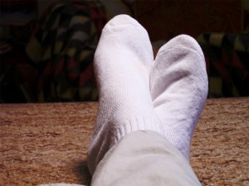
Do you sweat excessively? Do your socks become moist as a result? I'm Doctor [first_name] [last_name], and today I would like to speak to my friends in [city] about the connection between excessive sweating and fungal nail. When you sweat excessively, your skin remains warm and damp for an extended period of time. This environment presents an optimum opportunity for fungus to develop and especially attach itself to the nail. Those with this condition need to regularly be on guard against potential infections.
If you think you may have developed fungal nail, I invite you to visit my office here in [city].
Foot Diseases Swimmers Should Guard Against
Are you part of a swim team? Or are you simply an avid swimmer? I'm Doctor [first_name][last_name], your hometown podiatrist in [city], and today I would like to talk about foot diseases that swimmers need to be especially aware of. There are a number of foot ailments that arise as a result of having wet feet or walking in communal areas such as locker rooms and swimming pool platforms. For instance, HPV, the human papilloma virus, can easily be contracted in these environments and cause plantar warts. Fungal nail also develops as a result of picking up bacteria from these areas. If you love to swim, try to wear something on your feet as much as possible when you exit the pool. Try to keep your feet dry as well with a simple towel rub. I invite you to come see me, Doctor [last_name], here at my office in [city] where we can talk about these issues more.
Dry Heels
Are your heels cracked and dry like the Arizona desert? Is the embarrassment of the condition of your heels causing you to hide your feet? Hi, I'm Doctor [first_name] [last_name], a podiatrist right here in [city]. I encourage you to be proactive and do something about your condition today. There may be a number of reasons why your heels are dry. It could be due to a lack of hydration. It could be due to a skin condition. Or, there may be other underlying issues with your health that you are unaware of. If you have cracked and dry feet, I invite you to come to my office here in [city] and let me take a look.
Foot Surgery
Sometimes having foot surgery is a necessity. Hi, I'm Doctor [first_name] [last_name], a podiatrist in [city], and today, I want to calm the fears of those of you who may be in need of foot surgery. Foot surgery is often a welcome help to those who have painful conditions such as bunions or hammertoes. If these ailments have progressed to the point that other treatments are ineffective, then the podiatrist may need to schedule a corrective operation. In the end, being able to walk again without pain or deformity is an immense blessing that is well worth the procedure. If you have problems with your feet, I encourage you to come see me, Doctor [last name], at my office here in [city].
One Hundred Foot Muscles
Did you know that there are over 100 muscles, ligaments and tendons in your foot? I'm Doctor [first_name] [last_name] and today's post is for residents in [city] who suffer with foot pain. Since there are so many muscles in your foot, if even one of them is torn or stressed, you can be in a lot of pain. There are various factors that cause muscle pain: obesity, sports injuries and even improper footwear. If you are experiencing pain in your feet, come visit me at my office here in [city] and let me help diagnose the problem. No one can guess which one out of the 100 is injured on their own; only a professional can make that conclusion.
Foot Pain: 33 Joints
Did you know that there are 33 joints in each foot? Hi, I'm Doctor [first_name] [last_name], a podiatrist from [city], and today's blog is about -- you guessed it! Joints! Most people don't think about the joints in their feet until something goes wrong. One of the most common diseases affecting the joints is the formation of bunions, in which the joint of the big toe protrudes due to extra bone forming. A painful fluid-filled sac may also develop near this area as well. If you are suffering from pain in one or more joints in your feet, I encourage you to come see me, Doctor [last_name], at my office here in [city].

The Importance of Wearing Cotton Socks
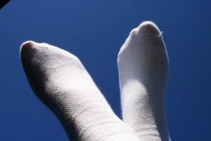
Your feet need to breathe. Hi, I'm Doctor [first_name] [last_name], a podiatrist in [city], and today I would like to talk to you about choosing your socks wisely. Fabrics differ in their ability to absorb moisture and allow the skin to breathe. When it comes to socks, it is preferable to choose cotton fabric rather than nylon or wool, as it keeps feet dry and airy the best. This is important because fabrics that remain wet from perspiration can cause feet to develop bacteria and fungus, which can turn into ailments like fungal nail. If you think you may have developed bacterial issues or even fungal nail, I invite you to stop by my office here in [city].
What Causes Bunions?
Hello, Doctor [first_name] [last_name] here. Today, I would like to teach my friends in [city] who are suffering with foot pain about the deformity known as the bunion. Some may wonder what causes a bunion in the first place. After all, a bunion is simply the protruding of the joint of the big toe. Bunions occur because of a misalignment of the toe, which is often triggered by improper footwear that causes cramping. However, it can also occur because of existing nerve conditions or Rheumatoid Arthritis. It is important for those who suffer with bunions to seek a professional diagnosis of the root cause of their problem. I invite you to come to my office here in [city] and let me take a look.

Peripheral Vascular Disease and Diabetic Foot
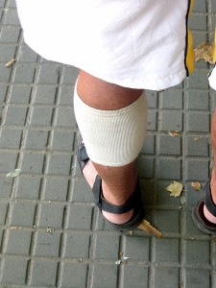
Do you suffer with peripheral vascular disease? Do you also have diabetes? If so, today's blog is for you. This is Doctor [first_name] [last_name], your friendly foot doctor in [city], and today I want to explain why these two types of diseases need to be monitored very carefully. Peripheral vascular disease is a condition where the arteries narrow, thus decreasing circulation. When blood is not circulating properly, it deprives the body of needed oxygen, which allows the body to heal when wounded. Therefore, if you have diabetes, which is also accompanied by neuropathy - the loss of feeling in the legs and feet - you could wake up one morning to a surprise wound that is terribly swollen because you could not sense it at the onset, and it could not heal properly. If you have peripheral vascular disease and/or diabetes, I invite you to allow me, Doctor [last_name], to help you keep them under control.
The Connection Between Fungal Nail and Ingrown Toenails
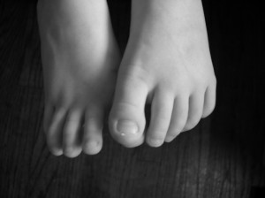
Did you know that an ingrown toenail can develop out of a fungal nail condition? Hi, I'm Doctor [first_name] [last_name] and today, I would like to speak to foot pain sufferers in [city] about the connection between these two conditions. Bacterial or fungal conditions can sometimes cause nails to thicken or widen, which may result in the nail curving down into the sides of the bed and puncturing the skin. When this occurs, you have in essence an ingrown toenail. To avoid these conditions, try to keep your feet as dry as possible at all times. If you have fungal issues or have developed an ingrown toenail, I want to help you feel great again. Come visit me, Doctor [last_name], at my office here in [city].
Cotton Balls: An Ingrown Toenail Faux Paux
Do you place cotton balls under your ingrown toenails to try to relieve the pressure? Don't!! This is Doctor [first_name] [last_name], your favorite podiatrist in [city], and today, I want to tell you why. Cotton balls, especially if filled with some kind of medicinal solution or other fluid, can cause the toe area to remain moist and warm, which is the exact environment needed to create the growth of bacteria. Taking this risk creates the possibility of developing an infection or condition such as fungal nail. If you have an ingrown toenail, it is best to see a podiatrist. I invite you to see me, Doctor [last_name], at my office in [city].
Irritating the Ball of the Foot
Our feet withstand a lot of abuse. But sometimes, they can't take any more. Hi, I'm Doctor [first_name] [last_name], a foot doctor of choice in [city], and today's blog is about the condition called Morton's Neuroma, which can develop due to a repeated irritation of the ball of the foot. If you're an avid sportsman and are often involved in activities such as basketball, tennis or jogging, the ball of your foot may experience irritation from long periods of pounding the pavement and/or rubbing against the bottom of your shoe. If the issue is not corrected by extra cushioning, the lateral plantar nerve may enlarge and combine with the medial plantar nerve, thus forming the painful condition called Morton's Neuroma. If you feel like you have a pebble under your skin when you walk, you may already have this condition. I encourage you to come see me at my office here in [city] and let me take a look.
Heel Pain and Cortisone Shots
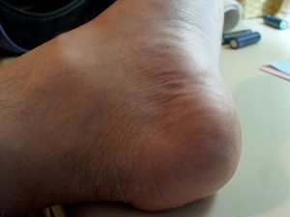
Heel pain can be excruciating. I know; I'm a podiatrist in [city], and I care for people with foot pain every day. I'm Doctor [first_name] [last_name], and today, I would like to talk to you about a common treatment for those that suffer with heel pain. Many seek out cortisone shots in an attempt to bring relief from the pain. However, these shots are often painful in themselves and are not always successful. Furthermore, cortisone shots can be expensive, yet still not help eliminate the problem. If you have heel pain, I invite you to come see your favorite foot doctor -- me, Doctor [last_name], of course -- at my office here in [city].

Potential Long-Term Problems with Neuropathy
Neuropathy is a condition that should be taken very seriously. I'm Doctor [first_name] [last_name], a foot doctor in [city], and today I would like to talk to you about the progression of neuropathy if left untreated. Neuropathy, which causes a person to lose their sense of feeling in their appendages such as their feet, can work its way up the limb if it is ignored. It can slowly creep up into the ankles and legs and cause undesired problems. If you have neuropathy, it is important to see a podiatrist regularly. I would love to be your selected podiatrist and help you to steer clear of physical problems.
From Awkward to Aligned
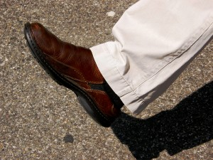
Are you suffering from the effects of flatfoot? Does your stride feel a bit awkward? I can help! Hi, I'm Doctor [first_name] [last_name], and I'm a local podiatrist here in [city]. I know that flatfoot doesn't only affect your feet. It can effect your whole skeletal system, since the loss of your arches throws your every step off kilter. The good news is that flatfoot is treatable. You don't have to go on suffering like this for the rest of your life. I encourage you to see me at my office here in [city], so we can talk about how we can get you back on track.
No Sharing
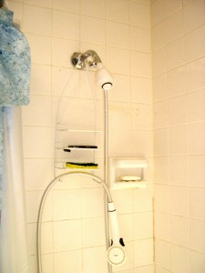
Although we were taught in kindergarten that it's good to share, when it comes to bacteria, there are some things you just shouldn't give to anyone else. I'm Doctor [first_name] [last_name], a podiatrist here in [city], and today I would like to tell you about the HPV virus that causes plantar warts. If you become stricken with the virus, it is possible to spread it to others in your family, or to your teammates if you play on a sports team. This virus is most commonly contracted through shower floors or communal areas such as locker rooms or pool platforms. If you have plantar warts due to the HPV virus, it is important to seek professional help in eliminating the problem, so that you do not spread the condition to others. I invite you to visit me at my office here in [city], so that I can help.
Keeping Your Feet Clean
Hi, I'm Doctor [first_name] [last_name], and today's blog is about the importance of keeping your feet clean---something that all residents in [city] should know, but need to put into practice. Scrubbing the feet daily with soap and water helps to eliminate germs that may have collected on the feet, including any bacteria that might be lingering in moist places, such as between the toes. This helps to reduce the risk of developing issues such as fungal nail, which can turn into other problems like ingrown toenail, as well as a number of other ailments. Most of all, scrubbing the feet helps to eliminate the odor associated with dirt, perspiration and bacteria---a common problem among many. If you're looking for a foot doctor to help you keep your feet healthy and beautiful, I invite you to consider visiting my office here in [city].
Poor Nutrition and Foot Fractures
You may not think that nutrition has any bearing on acquiring a foot fracture, but it actually does. Hi, I'm Doctor [first_name] [last_name], a podiatrist in [city], and today I would like to talk to you about the connection between these two issues. Your body needs nutrients to stay strong and healthy. When the body lacks these nutrients, such as calcium, the bones become weaker and more at risk for fractures or breaks. Therefore, it's important to maintain a good, healthy diet filled with fruits and vegetables, grains, dairy and lean meats. If you think you may have a foot fracture or other abnormality of the foot, I encourage you to visit me, Doctor [last_ name], at my office here in [city].

Strokes and Hammertoes
Although many may not know it, those who have suffered a stroke may be prone to developing hammertoes in some cases. Hello, I'm Doctor [first_name] [last_name], a foot doctor in [city]. Allow me to explain. Many times strokes result in brain injuries that can leave a weakness in various muscles, including in the legs and feet. This sometimes results in "neuromuscular impulses," which can include the curling of toes. If you are experiencing an unusual bending of your toes, see a podiatrist right away. I'd love for you to come visit me in my [city] office.
Chronic Ankle Instability
Chronic ankle instability is one of the possible repercussions of not treating an ankle sprain in time. Hi, I'm Doctor [first_name] [last_name], a podiatrist in [city], and today I want to talk to you about the importance of dealing with an ankle sprain at the onset. Like other foot ailments, ankle sprains only get worse if left untreated. Chronic ankle instability may result in some cases, in which the ankle frequently gives when when the person walks. It's like feeling part of your leg go limp all of a sudden. Some may also develop weakness higher up in the leg. If you have an ankle sprain or suspect that you do, see a podiatrist right away. I invite you to come to my office here in [city] for treatment that you'll be pleased with.
Pregnancy and Your Feet
Women who are pregnant need to take extra care of their feet. Hi, I'm Doctor [first_name] [last_name], and today I would like to talk to the mothers-to-be in [city] about pregnancy and the feet. There are a few issues that pregnant women need to look out for in their feet. First of all, since a woman's hormones increase when she is expecting, sometimes the ligaments in her feet and legs become relaxed and loose, including the arch muscles, which can lead to flat foot. Secondly, as the woman begins to gain weight, she may experience some pain in her heels, also known as plantar fasciitis. Women may also develop a condition called edema, where the feet swell with fluid. If you are expecting and are experiencing problems with your feet, I encourage you to come see me, Doctor [first_name] [last_name], at my office here in [city].
Why You Should Never Lotion Between Your Toes
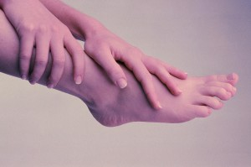
Doctor [last_name] [first_name] here; your favorite podiatrist in [city]. When you lotion your feet, do you include your toes? Well, today I would like to explain why doing so is not a good idea. Although it is recommended to lotion your feet regularly, it is important to avoid the toes as much as possible due to fungal susceptibility. The area between your toes is an ideal environment to hold in moisture, and so when feet are kept moist and warm after lotion is applied, bacteria and fungus can begin to grow. This can lead to conditions such as athlete's foot and fungal nail. If you think you've already contracted one of these fungal disorders, I encourage you to come see me, Doctor [first_ name] [last_name], at my office here in [city].
Keep Your Feet Elevated
If you suffer with neuropathy, or even if you don't, it is important to keep your feet elevated when seated. Hi, this is Doctor [first_name] [last_name], and today I want to talk to residents in [city] about why it's necessary to do so. Your blood needs to be able to circulate properly in order to give oxygen to the tissues of your feet. When your feet are left dangling, your blood isn't able to distribute nutrients as well. But, if you elevate your feet by resting them upon a stool or in a recliner, the circulation in your legs and feet is greatly improved. If you have problems with neuropathy, I encourage you to come see me, Doctor [first_name] [last_name], at my office here in [city].
Why Managing Your Blood Sugar is Important to the Health of your Feet
Doctor [first_name] [last_name] here; your favorite podiatrist in [city]. If you're a diabetic, I want to encourage you to manage your blood sugar, not only for your overall well-being, but specifically for the health of your feet. Making sure your blood sugar levels are within their proper range can help guard against numerous foot ailments. Diabetics can be prone to problems such as neuropathy, foot ulcers and even gangrene. These issues can escalate if not dealt with promptly. If you think you might have contracted any one of these ailments, please come see me, Doctor [first_name] [last_name], at my office here in [city].
Types of Foot Fractures
Doctor [first_name] [last_name] back again today to talk to residents of [city] about another issue regarding foot health, more specifically, foot fractures. Since there are so many bones in our feet---26 to be exact---a fracture can happen in a variety of areas, some which can even be difficult to detect with an x-ray. Types of foot fractures can include a calcaneous fracture (involving the heel bone), a Jones fracture (involving the bones near the little toe), and a lisfranc fracture (involving the midfoot). If you suffer trauma to the foot and believe that you have a fracture, please see me right away at my office here in [city].
Heel Spurs and Plantar Fasciitis
Sometimes heel spurs and plantar fasciitis can be confused with each other. Doctor [first_name] [last_name] here, and today I want to speak to those of you in [city] who are struggling with foot pain about these common disorders. A heel spur occurs when the plantar fascia muscle becomes so irritated that extra bone begins to form on the heel. Plantar fasciitis is the actual inflammation of the plantar fascia muscle. Both can be quite agonizing, but are very treatable. If you are experiencing pain in your heel area, stop by my office in [city] so that we can properly diagnose the problem.
Corns and Hammertoes
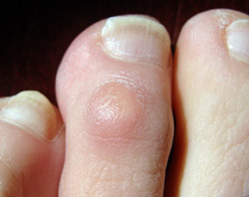
I'm Doctor [first_name] [last_name], a podiatrist in [city], and today I would like to discuss the foot disorder known as hammertoes. Hammertoes can hurt all by themselves, since they involve the unnatural bending of the toe, but they hurt even more when they are accompanied by a corn. Unfortunately, corns often develop on toes that are bent, as the sock or shoe constantly rubs against the skin to create a corn on the top or side of the toe. Thankfully, both corns and hammertoes are treatable, and we can help. Stop by my office here in [city] and let's take a look!
Advice for Those in Ballet
Do you or someone you know spend your free time in dance activities such as ballet? Hi, this is Doctor [first_name] [last_name], a podiatrist in [city], and today, I want to speak to those of you in ballet about special precautions that should be taken with your feet. When you wear ballet shoes, your feet are constricted to a very small space, while you are constantly putting them under pressure. Subsequently, you can develop blisters and calluses quite easily. Even more seriously, conditions such as sesamoids, plantar fasciitis, bunions, or hammertoes can also emerge. Seeing a podiatrist should be a regular practice for those who are in ballet in order to avoid problems. I encourage you to stop by my office here in [city], so that we can help.

Why are They Called Plantar Warts?
Doctor [first_name] [last_name] here; your favorite podiatrist in [city]. Do you ever wonder where plantar warts get their name? Let me tell you. When a wart that is caused by a virus develops on the bottom of the foot, it is called a plantar wart because the area of the foot where they develop is also known as the plantar section. Thus, the word "plantar" is merely used to denote where the wart has formed. If you notice a strange growth on the bottom of your foot and suspect that it might be a plantar wart, stop by my office here in [city] and let me take a look.

Guarding Against Flatfoot
You may have heard the stories of others that have developed flatfoot, and have been a bit concerned about developing the condition yourself. Hi, I'm Doctor [first_name] [last_name], a podiatrist in [city], and I have good news for you. There are some simple steps that you can take to avoid flatfoot. One of the most significant things that you can do for yourself is to buy shoes with good arch support. Don't just shop for fashion; shop for orthopedic value. Secondly, losing a few extra pounds can help guard against the condition as arch muscles sometimes collapse because of weight. If you already notice that your foot has lost its natural arch, come to my office in [city] at your earliest convenience, so that we can stop the issue from progressing into further problems.
Stopping a Bunion in its Tracks
"Bunion" is a dreaded word for many people when they go to a podiatrist. Hi, this is Doctor [first_name] [last_name]. I'm a podiatrist in [city], where a number of residents deal with problems with their feet, including bunions. A bunion is characterized by the bending of the big toe, followed by a protruding of the base joint. Individuals who develop bunions should visit a podiatrist at the first sign of the condition, as at this stage it is the most treatable. For some patients, simply switching out their footwear to shoes with a wider toebox can stop the issue in its tracks if it is caught early. If you think you have a bunion, don't live in fear. Come to my office in [city] and let's deal with the condition head-on!
Having a Neurectomy
Many people have heard of a hysterectomy or an appendectomy, but few have heard of a neurectomy. What is it? I'll tell you. I'm Doctor [first_name] [last_name] and I'm a podiatrist here in the [city] area. The procedure known as a neurectomy is most commonly associated with those that suffer from a condition known as Morton's neuroma. The disorder affects the nerves in the foot, especially those between the third and fourth toe. When other treatments fail, a neurectomy may be the only resolution. It involves the removal of the enjoined nerves that are causing the problem. Neurectomies are last resorts at my office here in [city]. If you deal with Morton's neuroma, let me help you stop the condition before it progresses any further.
No Fear of the Foot Doctor
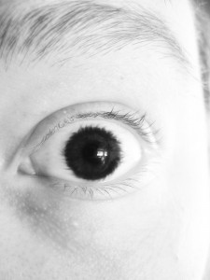
It's understandable why some may have a fear of the dentist, or going to their primary physician for a colonoscopy, or even having an annual physical. However, when it comes to the podiatrist, there is no need to have the slightest sense of fear. I know. I'm Doctor [first_name] [last_name] and I'm a foot doctor in [city]. Having an examination of your feet is one of the most easy and painless appointments you will ever have. In fact, if you're like many people, you may be ticklish on the bottom of your feet, and will especially have to hold in the giggles during your visit. Furthermore, our office in [city] fosters a very pleasant and relaxing atmosphere, which further makes your appointment a pleasure. We hope to see you soon!

