General Wellness is Important
Dear people of [city], [state],I am dedicated to bringing the best health and wellness to my friends, new and old. If you have any kind of health problems or are just interested in maintaining your general wellness, you should start by coming to my office at [address], [zipcode] so that you can be evaluated and get started on a treatment regimen that will keep you feeling great. When you are feeling good, you can accomplish a lot more, not only in your work but in the other aspects of your life as well. You know that when there is a problem of any kind with your health, it is enough to make everything go bad. Your health is important to you, no matter what you do for work and no matter what you enjoy as a hobby. Being healthy will help you to sleep better, work better and can even help you to maintain a normal weight. I want you to keep your health at its highest level and be happy. I look forward to working personally with all of the people in and around [city], whether they are concerned with their general health or if they have some specific health concerns to be worried about. Come to my office at [address], [zipcode] and we will work together on a treatment plan to keep you at your best health so that you can work and play. As the number one chiropractor here in [city], I look forward to helping everyone stay healthy and enjoy life for many, many years.

Repetitive Strain Injury
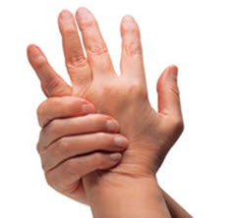
Hello! Dr. [first_name] [last_name] here, If you are suffering from any type of repetitive strain injury, whether it was caused by work, sport or entertainment, you need to get the help that you need. Chiropractic care can ensure that not only is the full range of motion restored to the area affected by your repetitive stress injury but is also able to lessen, and in many cases fully end, the pain that is felt in the area as well. Why not make an appointment at my office at [address], [zipcode]. I have worked with many patients in and around [city], and I know that as a highly regarded chiropractor that I can be very helpful to you, not only for this condition but for the health and welfare of you and your family. It is important that you understand that chiropractic care is an ongoing process and, of course, you will have to do your own part, including following specific and targeted exercises in addition to care in my [city] office. As an established and licensed professional in the city of [city], I have built up a practice based on successful care and a good reputation. No matter how your repetitive strain injury happened, your first step should be to call me, Dr. [last_name] at my [city] office. We can work together to establish the cause of your repetitive stress injury as well as work out a treatment plan so that you can be restored to full function and a pain-free level of health. Don’t spend another minute suffering from the pain of your repetitive stress injury, call me, Dr. [last_name], today at my [city] office and start working on feeling the best that you can.

Jaw Pain Caused by TMJ Can Be Treated by Your Chiropractor
Greetings [city], [state]! My name is Dr. [first_name] [last_name], and if you are suffering from jaw pain and live in the [city] area, instead of dealing with the pain through traditional dentistry, drugs and other therapies, why not come in for a consultation with me? My office is located at [address], [zipcode]. I can help to alleviate your suffering without causing you any additional pain. TMJ (Temporomandibular Joint) disorder is a painful condition that affects the jaw and can cause headaches, neck pain, earaches and jaw pain. TMJ does not just cause pain in the jaw. Many of my patients have reported experiencing ear pain, headaches and sore necks as well, all of which are conditions that I am able to treat. Part of your course of chiropractic treatment will involve the manipulation of the muscles around your jaw, which will improve motion and alleviate your pain caused by TMJ. Anyone who has ever needed to see a specialist for any type of disorder knows just how long it can actually take to get an appointment. If you are living with TMJ, you are no doubt in a lot of pain, and this is just going to get worse (or at the very least, not get any better) while you are waiting to see a specialist. I have successfully treated many patients suffering with TMJ at my office located at [address], [zipcode], eliminating their pain so that they can go on with their normal daily lives. And it won’t take nearly as long to get in to see me as it might to see a specialist.

We Can Help You Deal With Stress
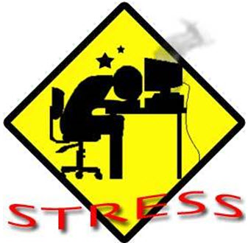
Hello [city], [state]! My name is Dr. [first_name] [last_name], and if you live in or around [city], I want to help you. As the number one chiropractor in [city], I am familiar with all of the many problems that can be seen in the area and would like to help all of my friends, new and old, so that they can live their life without problems and health concerns. One of the concerns that I see frequently in my [city] office is stress. Stress is not just a pain to deal with, but it can also cause aches and pains in the body, can interrupt life, disrupt sleep and keep you from eating. It can make other conditions worse and can even make you more susceptible to colds and the flu. It is important that not only the cause of the stress be addressed but the symptoms that it may cause as well. Stress can become a major part of your life if you let it, so do everything that you can to get it back under control. I have been working with people who are dealing with stress at my office that is located at [address], [zipcode]. Whether your stress is caused by your job, family or any other reason, I am ready and willing to work with you on your stress. We can work together here in my [city] office, so that you can deal with your stress and prevent it from causing any serious health concerns. Stress is no fun to have in your life and should be taken care of before it becomes much worse. Don’t let stress take away any of the fun in your life.

Slipped Disk
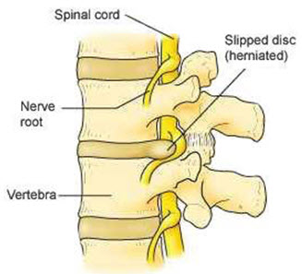
Hello folks! I am, Dr. [first_name] [last_name], the number one chiropractor in [city], [state] and I would like to help all of you, young and old with any slipped disc problems that you may have. Not only can a slipped disc cause pain, tingling and numbness, it can affect your sleep and other functions as well. Instead of allowing a slipped disc cause you pain and other problems, it is important to get the help that you need right away. There are far too many interesting activities in [city] to enjoy, and you will not be able to enjoy them if you are dealing with the problems caused by your slipped disc. Traditional medicine may not work out very well for you in all cases, and you may find yourself having surgery after medications have stop working. I want to help everyone in the [city] area to live comfortably. With careful manipulation and soft tissue massage, I can help restore some of the flexibility and range of movement in your back as well as relieving some of the pain that you are feeling. When traditional medicines and treatments have failed you, come see me, Dr. [last_name] at my [city] office for treatment. Of course, you will also have your own work to do, with special exercises that you will be encouraged to do at home. After a few treatments at my office located at [address], [zipcode], in addition to the exercises you are doing, you will be feel much better. I look forward to seeing you at my [city] office. Make an appointment today</a> so that you can get back to feeling good as quickly as possible. The office is conveniently located at [address], [zipcode], and is open at hours that can serve you well.

Head Pain Doesn’t Have to be Chronic
Have you been experiencing head pain, such as migraine headaches? Is this pain disrupting your everyday life? If you answered “yes” to these questions, then it is time that you and I get together for a consultation. My name is Dr. [first_name] [last_name], and I am the number one chiropractor specializing in head pain in the [city] area, and I can help to alleviate your pain using traditional chiropractic methods. Living with pain of any kind can cause many disruptions in your life, especially when your pain is from headaches. Not only are you experiencing pain, you more than likely find yourself constantly fatigued, or on the other end of the spectrum, having difficulty sleeping because of the pain. You don’t need to live like this. If you are in the [city], [state], I can help to eliminate your head pain. I see so many patients who are suffering needlessly from headaches at my office located at [address], [zipcode]. Often, head pain is caused by muscle stress, especially in the neck and shoulder muscles. With the right chiropractic care, you will find that your headaches lessen significantly, if not disappear altogether. I have the experience and use the latest chiropractic techniques to eliminate your head pain, as well as heal the source of that pain. If you are experiencing head pain and think that it may be caused by muscle tension, I can help you. Remember, head pain is not something that you have to live with forever. I can rid you of your pain by dealing with the source, without the need for drugs or surgery.
Dealing With Blood Pressure
Hello folks! Allow me to introduce myself. I am Dr. [first_name] [last_name], and I would like to help all of the people in and around [city], [state] with their health problems, including high blood pressure and other issues. As the number one chiropractor in the [city] area, I am able to assess health and devise a treatment plan that will allow you to get better control over your problems, often in ways that traditional treatment plans may fail. When you are not getting the support that you need from your medications or are continuing to have problems with blood pressure, it is time to make a call to me, Dr. [last_name], at my [city] office for an evaluation today. My office is located at [address], [zipcode].Blood pressure can be a serious condition to deal with and can be even more serious if it is a symptom of another condition. For instance, it may be a serious condition when it is caused by or related to kidney disease. Blood pressure, especially when it is not controlled correctly, can cause heart attacks or stroke. Here in my [city] office, I deal with blood pressure problems that are caused by a number of reasons, and I know that I can help you as well. Traditional medications can be dangerous, often with side effects that may be more frightening than dealing with the blood pressure itself.
You Don’t Have to Live With Chronic Pain
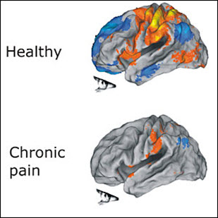
Millions of people around the world are suffering needlessly from chronic pain that can be managed with regular visits to a chiropractor. Hello [city], [state]! My name is Dr. [first_name] [last_name], one of the leading chiropractors, and I want to help you manage and even eliminate your pain so you can enjoy life on your terms. Often, physicians prescribe strong and addictive painkillers to their patients who are suffering from chronic pain. Or they advise invasive, exploratory surgery to find the root of the problem. Often, such forms of treatment are not the least bit necessary. If you live in the [city] area and are experiencing chronic pain of any kind, come and see me at my office that is located at [address], [zipcode], before taking the drastic steps of medication or surgery. I can help to eliminate your pain with specialized chiropractic treatments that will deal with the root of the problem that is causing the pain in the first place. When you visit my office, which is located at [address], [zipcode], the first thing that I will do is sit down with you and discuss your pain issues. Then I will make my own diagnosis of the problem and get to work at eliminating the problems that are causing your chronic pain. If you are suffering from chronic pain, I can help you. Come into my office for a consultation, followed by a series of chiropractic treatments that will get directly to the source of your problem and eliminate your pain forever. As one of the best chiropractors in the city, I have helped hundreds of patients in [city] with their pain issues, and I can help you too. Don’t suffer any longer.
A Chiropractor Can Help With Disc Herniation
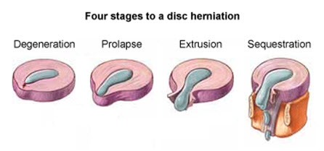
Hello! I want to help you with the pain and problems that you might have with disc herniation. There are many symptoms that you might have with disc problems, including pain, numbness, tingling and other sensations. You may also have problems moving around the way that you would like to, working or getting around the streets of [city]. Disc herniation can be serious, whether you are young or old, and should be treated in the most effective way possible. Traditional medicine may take months to simply find the problem, costing huge amounts in doctor’s office visits and expensive testing. After the doctors in[city] find the disc problem, you may be treated with medication and possibly with surgery, however, these will not always be effective. If regular treatments are not working for you any longer or you would rather not deal with surgery at all, you may need a new plan of action. In my [city] practice that is located at [address], [zipcode], I will help you to work toward greater relief from the pain and other symptoms of disc herniation. While I will help you with manipulations and soft tissue massage, you will have your own work to do too using special exercises and techniques, so that together your disc herniation can be taken care of. Don’t waste another minute being in pain or dealing with other symptoms. You need to get back to good health without pain and suffering so that you can work and play to the best of your ability in [city].
The Right Chiropractor Can Eliminate Your Neck Pain
Hello there [city], [state]. Have you been dealing with neck pain, only to find that none of the treatments that you have tried in the past have actually worked? Are you looking for a way to manage and treat your neck pain without taking addictive prescription drugs or undergoing invasive surgery? My name is Dr. [first_name] [last_name], the top-most chiropractor in[city], and I am the person who can help to ease and even eliminate your neck pain, without the use of drugs or surgery. I see hundreds of patients in my office at [address], [zipcode] who are dealing with neck pain, and their pain is caused by a number of conditions. Often, this pain can be attributed to an automobile accident or other types of accident. Other times, neck pain is the result of too many hours spent in front of a computer. No matter what the reason for your neck pain is, a visit with me at my office located at [address], [zipcode], will start you off on the right foot to living pain-free. Neck pain certainly doesn’t have to be a permanent condition, and it is not a condition that must be treated with drugs or surgery. When you come to see me to help you with your neck pain, I will first conduct my own examination so as to know exactly what we are dealing with. Then I will set about finding the right course of chiropractic treatment for your neck pain. So, if you are living in the [city] area and have been suffering with neck pain, suffer no longer. My office is located at [address], [zipcode], and I am here to eliminate your pain.

Pinched Nerves Can Be Healed
Are you suffering from the pain caused by a pinched nerve? Do you find that traditional treatments just aren’t all that they’re cracked up to be? Maybe what you need is not traditional drugs or surgery, but the treatment that only an experienced, specially trained chiropractor can provide. Let me introduce myself. My name is Dr. [first_name] [last_name], and I am one of the leading chiropractors in [city], [state], who is the experienced and qualified to help treat your pain caused by pinched nerves. A pinched nerve, also known as a subluxation, is basically a misalignment. This misalignment causes pressure on the nerves, which in turn can cause the nerves to become pinched, thereby causing extreme pain. Pressure can come from a number of sources, including tendons, muscles and bones. A pinched nerve can be caused by simple everyday movements, such as bending and twisting. It only takes the slightest wrong move to cause pain, and if you are experiencing pain caused by a pinched nerve, I want to help to alleviate your pain. As a practicing chiropractor in [city], I am trained to treat disorders involving the skeletal system as well as the muscles and nerves. When it comes to treating your pinched nerve, I manipulate the muscles, tissues and bones to alleviate the pressure that is causing your pain. Before you decide to undergo painful surgery that will take a long time to heal from, come in and visit me at my office, conveniently located at [address], [zipcode] in [city], [state]. I can help to treat the source of your pain, and you won’t have to deal with surgery, drugs or other forms of therapy.

Stiffness/Soreness in Muscles
Are you suffering from stiffness or soreness in your muscles? Have conventional drugs and other treatments not helped to relieve your pain? If you are tired of dealing with constant stiffness and soreness, it’s time that you come to see me. I am Dr. [first_name] [last_name], and I am one of the topmost chiropractors in [city], [state], with the training and experience to help patients manage a variety of different aches and pains, including stiffness and soreness in the muscles. There are many causes for sore, achy muscles. Often, patients come to see me in my office at [address], [zipcode] because they find that they are sore following an injury. Others are in pain just because they happened to move the wrong way. Often, when people experience muscle pain and stiffness, they tend to rely on over-the-counter and prescription medications, such as painkillers and muscle relaxants. Unfortunately, these can not only become addictive, but the more they are used, the less effective they become. Instead of relying on medications to deal with pain for the rest of your life, why not make an appointment at my [city] office, and see me for a consultation. I have the experience and training to help you manage your pain and deal with the root of your pain, with the goal of eliminating it altogether. Stiffness and soreness in the muscles is something that millions of people deal with, unnecessarily, each and every day. If you are living in the [city] area and are dealing with pain and stiffness in your muscles, come and see me, Dr. [first_name] [last_name], for a consultation. My office is located at [address], [zipcode].
Suffering from Chronic Fatigue?
Hello to all you lovely people in [city], [state]. Allow me to introduce myself. I am Dr. [first_name] [last_name], and I am the leading chiropractor in the area. I know that many of the people here in [city] are dealing with problems that are related to fatigue and I would like to offer my support and treatment. Not only does fatigue keep you from enjoying your life to its fullest, it can affect your work, your family relationships and even your general health. No matter what is causing your fatigue, you need to find a way to deal with it and to get back to living your life the way that you want to. Did you know that fatigue can be a condition on its own or in some cases can be a symptom of other serious conditions? While some cases of fatigue can be handled by a traditional doctor, in other cases, especially those cases that do not have an exact cause, the problem can continue with no help in sight. Instead of suffering with problems related to fatigue, you need to seek out the help that you can get from me, Dr. [last_name], at my [city] office that is located at [address], [zipcode]. Through soft tissue massage and careful manipulations, I can help to address the problems that you have with fatigue so that you can get back to living your life. There are too many interesting activities in and around [city] to allow fatigue to slow you down. It is time to get back to having fun and doing all of the things that you want to do as well as the things that you have to do. My [city] office located at [address], [zipcode] is open during convenient hours so that I can treat all those that need help.

Chiropractors Treating Ear Infections?
If you are like the majority of people, you probably think that you only need to visit a chiropractor when you have a sore back or other muscle issues. Did you know that chiropractors can treat many types of ear infections as well? My name is Dr. [first_name] [last_name], one of the city’s top chiropractors, specializing in treating muscle and soft tissue conditions that can cause ear infections. If you have an ear infection and are living in the [city] area, drop by my office located at [address], [zipcode] for a consultation, and I will diagnose the problem and quickly get to work on a course of therapy. Often, many earaches are caused by a misalignment or subluxation, which prevents the proper draining of fluid from the middle ear. In my [city] office, I use chiropractic techniques that will help to correct this misalignment, which can actually eliminate your earaches and prevent future ones as well. Earaches are a common affliction in children, and over the course of my many years of being in practice in [city], I have helped to ease the pain in many children who experience earaches. The first thing that I do of course is to correctly diagnose the source of the earache. If you or your child are experiencing earaches, it may be caused by some sort of skeletal or muscular misalignment, and a chiropractor such as myself, Dr. [first_name] [last_name], can help to alleviate your pain, and in many cases, eliminate it altogether. Don’t suffer with earache pain any longer, and don’t let your children suffer, because it is not necessary. Come and see me at [address], [zipcode], and get on the road to being pain-free.
Suffering from Hay Fever? Visit Our Office
Hello to all my friends, new and old, in [city], [state]. I would like to provide you, your friends and family with the best treatment plan for hay fever or any other problems that you may be having. Think about the problems that are caused by your hay fever, including itching, sneezing and reddened eyes. You may not be able to sleep very well. You will not enjoy going out with friends in [city], especially for outdoor activities. There are a number of ways to handle your hay fever, including traditional medications and treatment plans. However, these can be expensive and time consuming, as well as potentially ineffective. If you have tried these types of treatments already without any success, you might consider calling me, Dr. [last_name], and making an appointment to come into my [city] office located at [address], [zipcode] for more effective care for this problem. Not only can you find the right treatment plan for your hay fever at my [city] office, you can even find methods of dealing with other problems. I want all of the people who live in and around [city] to feel their best, no matter what their problems might be. It is important that you get the treatment that you need, not only to deal with the immediate symptoms but the long-lasting problems that it can cause as well. Don’t wait any longer, there is too much fun and excitement in the [city] area to be bothered by hay fever. Why suffer when there is a treatment that works? My office is conveniently located at [address], [zipcode].
Maintain Proper Posture to Alleviate Pain
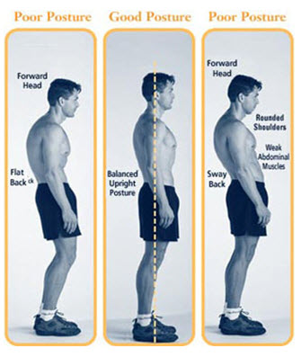
Poor posture is one of the main culprits of back pain, which is suffered by millions of people worldwide. Did you know that a good chiropractor can help to correct your posture and possibly eliminate much of your body pain? If you are living in the [city] area and find that you are experiencing pain that may be due to poor posture, I am available to sit down and have a consultation with you and discover how, together, we can eliminate your pain. Poor posture can cause a number of issues, including back pain. It can also make you more susceptible to injuries and weak muscles. These are issues that I can help you to deal with, and with the proper chiropractic care in my office at [address], [zipcode], you will soon be pain-free. It is not difficult to maintain perfect posture throughout the day, and when you do, you will find that you experience much less back pain. If at any time of the day you find yourself slouching, all you have to do is raise your shoulders to your ears, pull them back and then drop them down. It’s as simple as that to get yourself into perfect posture. Not only does poor posture cause a host of aches and pains, it also causes you to cast the image of someone who has little self-confidence. When you have good posture, you will stand straight and show the world that you have plenty of confidence. I can help to treat your poor posture so that you will stand proud and walk tall.

Spine Disc Degeneration
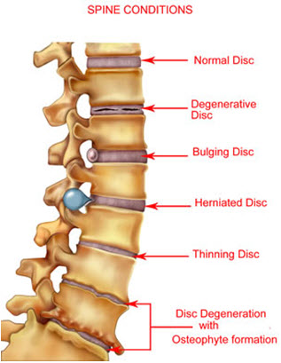
Hello [city], [state]! I want to help you, your friends and family deal with the pain and suffering that they may have from spine disc degeneration. There are a number of problems that you can have from this condition, including pain, tingling and numbness. You might also find yourself dealing with other problems, including the inability to walk or sleep at times. Did you know that you could even lose height if you have spine disc degeneration? It’s a fact! You could lose as much as two to three inches of your height because of spine disc degeneration, in addition to the pain and other problems. I have seen and treated many people who have been shocked that this has happened to them. I am able to help you in my [city] office with ongoing treatment that can help to relieve the pain that you might be feeling. Spine disc degeneration can interfere with work or other activities, as well as keeping you from comfortable sleep every night. The longer that you go without treatment for this condition, the longer it may take to get back to a good comfort level. I implore you to take a good step forward by calling me, Dr. [last_name], at [phone] to make an appointment as soon as possible so that you can get back to living and enjoying your life in [city]. Part of the treatment that you will see here with me, Dr. [last_name], will include soft tissue and joint manipulation, as well as specially designed exercises to relieve the pain that you are feeling. My office is located at [address], [zipcode].
Visit a Leading Chiropractor for a Sports Injury
Hello everyone in [city], [state], I am the number one chiropractor in the [city] area. It doesn’t matter to me if you pulled a hamstring playing basketball, twisted a knee playing hockey or even gave yourself a wrist injury twirling rope for your daughter’s double Dutch team, a sports injury is painful to deal with, and if it is not cared for properly, can become worse and worse. That’s no fun, is it? Whether you have a minor sports injury or one that is more serious, it is important to get it taken care of as soon as possible so that you can get back to normal or as close as possible. Many of the people in [city] may choose to go to traditional doctors for expensive tests, medications with potentially dangerous side effects and eventually the threat of surgery, which is frightening for many people. This may not be necessary, and here in my [city] office located at [address], [zipcode], we can discuss the other, alternative options that can help to treat your sports injury, once and for all. My [city] practice will work with you to find an acceptable treatment plan. With careful manipulation of the soft tissues involved in the sports injury, I can help you to work through the pain. You will have your own part to play as well - you will have exercises that will help to get your function back faster and will help to reduce the pain, with the goal of getting rid of it completely.
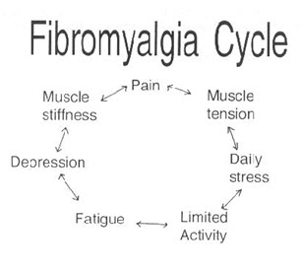
Fibromyalgia Can be Managed With Chiropractic Care
Hello [city], [state]! My name is Dr. [first_name] [last_name], and I am a leading chiropractor in [city]. If you are suffering from fibromyalgia, there are steps that you can take to help yourself, and one of those steps is to visit me at my office located at [address], [zipcode]. I have successfully treated many patients with fibromyalgia and will be able to help you to manage your pain as well. You won’t have to live with the chronic pain caused by fibromyalgia any longer when you follow the proper course of treatment, which includes regular visits to my office. Fibromyalgia is a condition that causes pain in the muscles and soft tissues throughout the body. Because this is a condition that is affected by the central nervous system, people with fibromyalgia feel extreme pain where others may feel mild pain, and often, even when there has been no injury. Fibromyalgia can cause a loss of energy and an inability to sleep, but it is a condition that is controllable. In fact, there are many ways that I as a chiropractor can help fibromyalgia patients deal with their pain. The last thing that anyone needs to deal with is pain. If you are dealing with fibromyalgia, you know that this is a chronic condition that is never going to go away. But with the proper treatment, including the kind of chiropractic care I offer at my clinic, which is located at [address], [zipcode], you can live a normal life, relatively free of pain from your condition. Do not suffer when there are chiropractor treatments that work. Remember, Dr. [first_name] [last_name], has a solution for your fibromyalgia pain.
Allergies and Chiropractic Care
Do you suffer from environmental allergies such as scent allergies, hay fever and allergies to smoke and other pollutants? Have you ever thought about seeing a chiropractor for your allergies? Okay, so you may be thinking, “chiropractors work on backs, so what can they do for my allergies?” Well, you would be surprised. My name is Dr. [last_name], and I am a top chiropractor located in [city], [state]. I specialize in the treatment of allergies, and I can help you to manage your allergies so they do not interfere with your daily life. There are many allergy symptoms that I can help relieve you of through specialized chiropractic care, such as acupuncture and acupressure. Some of the symptoms that you may be experiencing that I can help you with include headaches, asthma, digestive problems, anxiety, skin conditions and fatigue. These are all symptoms that can disrupt your life, and visiting me at my office in [address], [zipcode] is your first step to becoming symptom-free from your allergies. Most people who have allergies rely on medications to ease their symptoms. Why settle for just easing your symptoms when I can help to nearly, and in many cases, completely, eliminate your allergy symptoms and help keep you symptom-free for life? Visits to my office at [address], [zipcode] are walk-in or scheduled, and my treatments are non-invasive. Of course, the first thing I will do is conduct complete allergy tests, so I can determine exactly what is causing you irritation and how to go about correcting it. If you live in the [city], [state], and are suffering from the symptoms of your allergies to the point where they are affecting your normal daily activities, remember to call or drop by to Dr. [last_name]'s office.
How Can Your Whiplash be Treated?
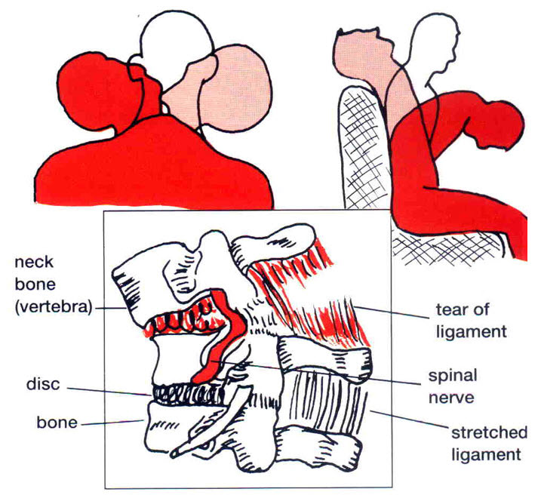
Have you been an accident and wound up with whiplash as a result? Are you experiencing pain and immobility because of your whiplash? Hello. I am Dr. [last_name], one of the best chiropractors in [city], [state], and I want to help relieve you of pain you may be suffering as a result of whiplash. In my many years of practice in [city], [state], I have successfully treated hundreds of whiplash patients, and I can treat your whiplash as well. Whiplash is a painful condition in the neck that is often caused by the forward and backward motion of the head and neck, often occurring during accidents such as automobile accidents. Many patients who have whiplash report that they experience severe pain and, often, a lack of mobility. The first thing I will do when you visit my office at [address], [zipcode], is diagnose your exact condition, evaluating your complete spine, including your mid and lower back, and determine the areas that are immobile due to your whiplash and how to go about treating the problem. Some of the treatment methods I will use to treat your whiplash include muscle and skeletal manipulation, which will help to treat your injury and allow your joints to once again function properly. In my office at [address], [zipcode], I can show you many exercises that you can do at home between visits that will help to eliminate your pain as well. There are various stages of injury, and I will treat each stage accordingly. If you live in the [city] area, and are suffering from the pain and immobility caused by whiplash, I want to help you.
Spinal Injury
Hello people of [city], [state], I am the leading chiropractor in the area and I want to help you with your spinal injury and the problems that it may be causing. Whether your spinal injury is caused by work, an accident or sports, you certainly want to make sure that you are getting the best care possible so that you do not have to deal with the pain, numbness, tingling or other problems that can be involved with your spinal injury. A spinal injury can leave you unable to work, play sports or even perform your daily activities without pain and discomfort. It can also cause other problems like weak, numb or tingling legs and may even cause you to need to use a wheelchair or crutches. Traditional doctors may suggest medications or may even suggest that you need to have surgery. Not only are these frightening to think about but they can be expensive as well, and in many cases, may not even be effective at all. As part of the medical community in [city], [state], I have sought to bring relief to the people in the area, not only from pain but from the inability to move the way you would like to. You do not need to live with the pain and the inability caused by a spinal injury, not when you can come and see me, Dr. [last_name], in my [city] office located at [address], [zipcode]. Get a [offer] by calling [phone] or clicking the link below so that we can see the extent of your injury and find the right treatment plan for you. Not only will we find the right form of treatment, you will also have your part to play in your own recovery with special exercises that will help take care of the pain and problems you have with your spinal injuries.
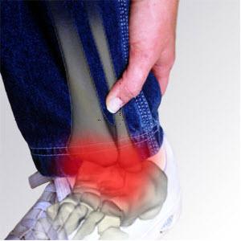
Eliminating Ankle and Foot Pain with Chiropractic Care
Hello. My name is Dr. [last_name], and I am one of the most well-known chiropractors in [city], [state]. Are you dealing with ankle or foot pain that conventional treatments do not seem to be helping? If you are suffering from pain in your ankles or feet, I can help to eliminate your pain by getting to the actual root of the problem that is causing the pain. There are many things that can cause ankle and foot pain. Sprains and strains are common injuries that can cause quite a bit of pain, and I can easily work with your muscles to get rid of the pain, by healing the sprains and strains through a series of chiropractic treatments. Many of my patients complain of foot pain, and after a thorough examination in my office at [address], [zipcode], I have discovered that the source of that pain is a misalignment in the foot. I will work with the bones and muscles, manipulating them to re-align the foot and ease your pain. If you live in [city], [state], and are suffering from ankle or foot pain that is causing you problems with mobility, a visit to me for a consultation is your first step to becoming pain-free. Ankle and foot pain can be extremely annoying, and can make it difficult for many to get around. The pain can get so intense that walking is nearly, if not completely, impossible, making it difficult for patients to live their normal lives. If you are dealing with ankle and foot pain and live in [city], my office is conveniently located at [address], [zipcode], and I am here to help you get your mobility back and not have any more pain.
Pain Caused by Rotator Cuff Syndrome is Treatable
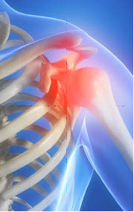
Are you suffering with the pain of rotator cuff syndrome? Do you find it difficult to perform routine daily tasks that involve using your arms and hands? If you are experiencing these problems, instead of taking harmful medications or undergoing invasive surgery with a recovery period of months, why not try visiting a chiropractor? I am Dr. [last_name], a highly respected chiropractor in [city], [state], and I can help treat your rotator cuff syndrome and eliminate your pain and suffering from this condition. First of all, let’s discuss what the rotator cuff is. There are ligaments and a group of muscles in the shoulder that connect to the main articulation, which is known as the rotator cuff, and injuries to the rotator cuff can cause extreme pain and the inability to move properly. I have successfully treated many patients in my office at [address], [zipcode], and I am positive that I can treat your condition as well. Some of the forms of treatment that I use to treat rotator cuff syndrome include muscle manipulation and soft tissue massage. I will also give you special exercises that will compliment my course of treatment. In no time at all, you will be living pain-free and experiencing full mobility. Again, if you are living in the [city], area, my office is conveniently located at [address], [zipcode]. Call or drop by to <a href="[site_url]/freeconsultation">arrange for a consultation</a>, where I will diagnose the root of your problem and start the proper course of chiropractic care that will eliminate your pain, once and for all. Rotator cuff syndrome may indeed be a painful condition, but I will work with you to ensure that your pain is cured and that you are able to live a normal life, free of shoulder pain caused by rotator cuff syndrome.

Chiropractors Can Help With Your Sleep Disorders
Hello people of [city], [state].Are you getting the sleep that you need every night? Are you tossing and turning every night and then waking up feeling more tired than you did when you went to bed? I am Dr. [last_name], the premiere chiropractor in the [city], area, and I want to help you with your sleep disorders no matter what they might be. There are a number of different sleep disorders that might be a problem for you, whether they are making you sleep too little or sleep too much. If you are not getting enough sleep to be at your very best, it is time to take the best step that you can to get back on track. Get yourself back to good health with chiropractic care, including manipulation and treatment. In addition to this care, you will have your own work to do, including special exercises that can help get yourself back to sleeping like you should. Sleep affects everything in your life, including the way that you eat and your mood throughout the day. There are too many things to do in the [city] area to let a day pass you by because you are too tired to get out and enjoy life. Call my office that is located at [address], [zipcode] and make an appointment right away so that you can get back to living your full life. I want everyone to know the Dr. [last_name], as the number one chiropractor in the [city] area. I can help you to deal with your sleep disorders so that your life can get back on track and you can enjoy all of the fun that [city], [state], has to offer.
Stop Suffering From Joint Pain
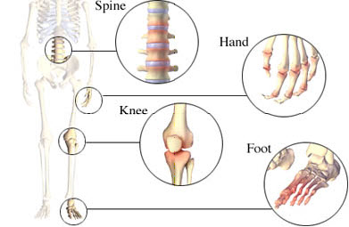
Does this sound like you…every day it seems more and more difficult to get out of bed because of chronic joint pain? Do you find it difficult to perform many of your regular daily tasks, things you never even gave a second thought to before? If you can answer these questions positively, then you really should seek out the help of someone who can eliminate your pain, without surgery or addictive drugs. You are probably thinking, “What can Dr. [last_name], do for me? I thought chiropractors only work on back pain.” Well, think again! There are many conditions that I can help you with because chiropractic adjustments can help with many other areas on the body, not just the spine. There are many ways that I can treat your pain, including disc decompression, spinal manipulation, physical therapy and exercises for you to do at home. Often, joint pain is caused by an underlying condition. After a thorough examination in my office at [address], [zipcode], where I can get a correct diagnosis of the actual problem that is causing the pain, I can start working on eliminating that pain and healing the condition that causes it in the first place. Joint pain is not something that anyone should have to live with. Often, it is caused simply by sprains and strains, and through chiropractic manipulation, you can soon be pain-free. If you live in the [city] area, and are suffering from joint pain that is affecting your life, come in and see me, Dr. [last_name], for a consultation. I will work to eliminate your pain and help keep you pain-free for life.
Sciatica Pain Can be Eliminated
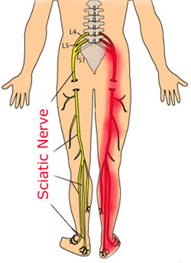
Often when patients come to me with leg pain caused by sciatica, it is really caused by something that goes even deeper. Hello. My name is Dr. [last_name], and I am one of the top chiropractors in [city], [state], and my office is located at [address], [zipcode]. I have been successfully treating patients experiencing pain from sciatica for many years, and I believe that I can help you too. More often than not, sciatica is not the cause of your pain. The sciatica is often a symptom of something else, such as disc tearing and spinal stenosis, which I can help treat through a number of chiropractic therapies, including spinal manipulation, stretching and resistance techniques, and trigger point therapy. I will also teach you exercises when you visit my office that is located at [address], [zipcode]. Sciatica is a painful condition that is the result of an irritation of the sciatic nerve, which is often caused by a herniated disc. Other causes of sciatica include irritations of the nerve caused by infections, tumors, injury and internal bleeding. Some of the symptoms that you may experience if you have sciatica include numbness, pain and burning or tingling sensations going up and down the leg, and often the condition can make walking extremely difficult. Don’t let this happen to you. I am able to treat your sciatica symptoms, and you won’t need to take any addictive medications or undergo painful surgery. If you live in the [city] area, and are suffering from pain caused by sciatica, call or come in to see me Dr. [last_name], for a consultation. I will conduct my own examination in my office at [address], [zipcode], and once I diagnose the cause of your condition, I will get to work on eliminating your pain completely.

We Can Help With Disc Problems
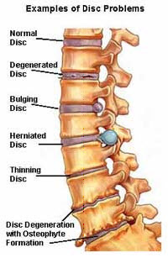
Greetings, [state]! I am Dr. [last_name]. If you live in or around [city], I am available to help you to deal with your disc problems and the pain they cause. As a highly regarded chiropractor in [city], I have successfully treated many patients. There are a number of causes for disc problems, and I have treated many cases in [city] involving all of the different types of disc problems. Disc problems are common conditions and can affect both men and women. Some of my patients here in [city] are having disc problems because of genetics, accidents, overuse, muscle strain, disc degeneration and other abnormalities in the muscles, the skeleton or the spine. As a chiropractor in [city], I specialize in the treatment of many of these problems, including treatment of the vertebrae and the muscles, and can help you to learn to effectively manage your pain. The pain can be mild to severe and may be bad enough to keep a patient bedridden at times. However, with effective chiropractic treatments in my office in [city], you can get rid of the pain. If you live in [city] and are dealing with the pain of disc problems, you should know that there is relief in Dr. [last_name]'s office. Stop dealing with the pain of disc problems now - visit me, Dr. [last_name], the premiere chiropractor in [city] so that you can get back to your life.
Dealing With Sprains and Strains
Hello there, [state]! If you live in or around [city], I am here to help you deal with the pain and discomfort of sprains and strains no matter what has caused them. As a well-known chiropractor in [city], I see patients dealing with various sprains and strains on a daily baisis. There are literally hundreds of causes of sprains and strains in the body. Sprains and strains are very common conditions and can happen to anybody at any time. In fact, I have seen patients in [city], who have sprains and strains as a result of accidents, poor posture, overuse, abnormalities in the bones and joints or even as the result of being overweight. As a chiropractor in [city], I specialize in the treatment of these problems. I can help you to learn how to deal with and manage this pain and in many of the cases, can eliminate it completely. Some of the symptoms that I have treated patients in [city] for includes stiffness from their sprains or strains, pain, tingling sensations, numbness and other problems. Through the careful manipulation of the muscles and soft tissues, I can help you to be relieved of your pain and slowly work toward restoring full movement to the area. Your treatment will take place in my office in [city]. If you are living in [city] and are trying to deal with mild, moderate or even severe pain from sprains and strains, there is no need to suffer any longer. You have other things to do rather than dealing with pain of any kind. When you are dealing with the pain of sprains and strains, visit me, Dr. [last_name], in [city] for treatment right away.
Shoulder/Arm Pain Can be Treated by a Chiropractor
Hello. My name is Dr. [last_name], and I am a chiropractor in [city], [state], I have successfully helped hundreds of patients who have experienced shoulder and arm pain, and I am certain that I can treat your pain too. There are many chiropractic techniques that I will use to help ease, and even eliminate, your shoulder and arm pain. Through a series of therapeutic exercises and adjustments in my office that is located at [address], [zipcode], I will be able to get to the root of your pain, and help you live an active pain free life. If you are living with shoulder or arm pain, you are doing so needlessly. You can come to see me, Dr. [last_name], in my office at [address], [zipcode], because I can get to the root of your shoulder and arm pain and will use the latest chiropractic techniques, as well as some tried, tested and true techniques, to eliminate your pain forever. Anyone who is suffering from shoulder and arm pain, and is living in the [city], area, should come in to see me, Dr. [last_name], for a consultation. My office is located at [address], [zipcode], and I am available to see you. I will diagnose your condition and work to create the best course of therapy for you as an individual. Not everyone benefits from the same treatments, and we will work together to find out which treatments work best to eliminate your pain.
Let Us Help With Your Scoliosis Treatment
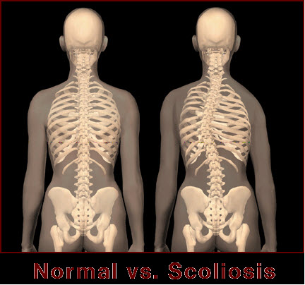
To all the folks in [state]! My name is Dr. [last_name], and if you live in or around [city], I am available to help you to deal with scoliosis and its problems. Known for my effective chiropractic treatments in [city], I have treated countless patients who are dealing with this progressive condition of the spine. Scoliosis is a progressive curving of the spine which is four to five times more common in young women than in boys the same age. There are a number of causes for this condition and I have treated many kinds of scoliosis and the pain that it causes in [city]. Scoliosis is a fairly common condition, but can lead to contraction of the ribs, compressing the heart and lungs, restricting both circulation and the breathing. It can also lead to quite a few other problems relating to pain and function of the spine and back area. In addition to my treatment and adjustments in my office in [city], you will learn special exercises to help to get you back to feeling well and without pain. In my chiropractic practice here in [city], I have treated patients for symptoms such as pain, stiffness, breathing problems and other increasingly more serious problems. Left untreated, scoliosis can lead to a bedridden young person. If you live in [city] and are suffering from the pain and other problems of mild to severe scoliosis, there is no need to suffer any longer or give up a single day of your young life. You have better things to do than to deal with this pain. So if you or your child is dealing with scoliosis, visit me, Dr. [last_name], well-known chiropractor in [city] and start getting relief right away.
Dealing With Migraines
My name is Dr. [last_name], and if you live in or around [city], I am available to help you deal with the pain of migraines. When the pain of dealing with migraines is interrupting your daily life, it is time to take action by coming to see me, Dr. [last_name] in [city]. I am a chiropractor in [city], and I have helped many patients deal with various types of headaches and migraines, even in those who have not had any success with the regular migraine treatments and medications. There are many causes of migraines and I have treated many of them in [city], involving many different types of these terribly painful headaches. Migraines are extremely common. Some of the patients that I see here in [city] are dealing with chronic migraines that can be caused by hormones as well as possibly stress and a number of other causes. As a chiropractor in [city], I specialize in treating the pain and underlying cause of these migraines as well as relieving the pain and stiffness that can affect the neck or upper back because of them. I can help you to learn to deal with some of the pain of these migraines, working to eliminate it completely. Some of the symptoms that I have treated patients for in my office in [city] include the blinding pain of migraines, light sensitivity, nausea and countless other problems. Some migraines may be caused by stress or by pinched nerves in the neck, so through careful adjustments, special exercises and regular treatment, we can work as a team to relieve the symptoms. If you live in [city] and are dealing with the pain of migraines, there is no need for you to suffer any longer. You have better things to do than to deal with the pain and other symptoms of a migraine, so visit [practice_name] in [city] and start working towards your best relief right away.

Suffering From Hip or Leg Pain? Contact Us!
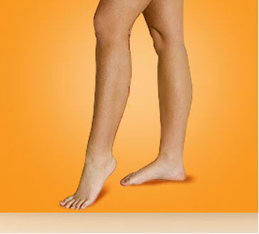
Hello, people of [state]! Allow me to introduce myself. I am Dr. [last_name], and if you live in or around [city], I am available to help you deal with your hip or leg pain. As a chiropractor in [city], I see loads of patients who are dealing with these types of pain every day. I have also successfully treated many patients in [city]. I have treated many cases of people suffering from hip or leg pain in [city]. Anyone of any age can get hip or leg pain for any reason. Some of the patients that I see here in [city] are having hip or leg pain because of accidents, strains or sprains, overuse, poor posture, spinal misalignment, as well as many others. As a chiropractor in [city], I have specialized in the treatment of many muscular problems. Some of the symptoms that my patients have come to my [city] office to be treated for include: mild to severe hip or leg pain, numbness or tingling sensations and other problems. Through the manipulation of the muscles and soft tissues, I can not only relieve the hip or leg pain, but can also work toward restoring full movement to the area. In [city], most people are aware of Dr. [last_name] effective chiropractic treatments. If you are living in [city] and suffering with mild to severe hip or leg pain, there is no need to suffer any longer. There are better things to do with your life than to deal with pain of any kind. Instead of dealing with hip or leg pain, visit me, Dr. [last_name], the number one chiropractor in [city] and get the relief that you need right away.
TMJ- Temporomandibular Joint Pain
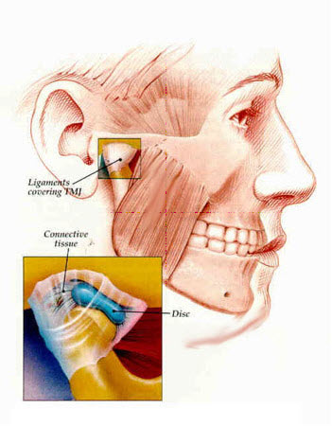
Greetings [city], [state]! </strong>Are you dealing with the pain of TMJ in your [city] home? Allow me to introduce myself. I am Dr. [last_name], a chiropractor in the [city], area. I want all of my friends and neighbors in [city], [state], to be free from the pain and other symptoms of TMJ, a painful disorder that affects your jaw and can lead to headaches and other problems. Did you know that TMJ can affect your sleep each night or can affect the way that you eat? Not only that, but it can lead to serious headaches which can also detract from living your best life and can leave you missing out on the fun and excitement that is offered in [city]. It is time to stop suffering with TMJ and also to stop trying to use traditional. Did you know that TMJ can affect your sleep each night or can affect the way that you eat? Not only that, but it can lead to serious headaches which can also detract from living your best life and can leave you missing out on the fun and excitement that is offered in [city]. It is time to stop suffering with TMJ and also to stop trying to use traditional treatments that may not work at all. There are some doctors who may spend many months trying to find the cause of your problems and then will still be unable to help you. It is important to keep a few things in mind when dealing with TMJ and chiropractic care. First, I like to explain to my patients in the [city] area that this is an ongoing process. Second, you will have your own special exercises to do as well, making you an integral part of your own care. Finally, chiropractic care is a great way to get your TMJ under control so that you can live your life the way that you would like.
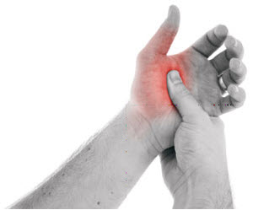
Repetitive Stress Injuries Should Not Disrupt Your Life
Hello. I am Dr. [last_name], from [city], [state]. As a chiropractor, I have helped hundreds of patients who were dealing with pain from repetitive stress injuries. I see more and more cases of it all the time. Many patients are coming to my office at [address], [zipcode], suffering from pain that is caused by repetitive stress injuries, for treatment that will eliminate their pain. Repetitive stress injuries are just that - injuries that are caused by repetitive movements. Many people who are in jobs that require a lot of typing, such as data entry, or other jobs that involve many repetitive movements, are susceptible to repetitive stress injuries, which can bring much pain to sufferers. There are many ways that I can work with your body to help eliminate pain caused by repetitive stress injuries, including muscle and spinal manipulation, massage and exercises. One way that I can help treat your repetitive stress injury is to help correct your posture. Often, these injuries are caused by poor posture, which is simple to treat. I will also work with your muscles and soft tissues, manipulating them to help them heal from the injury that is causing your pain. If you live in the [city], area, and are suffering from pain due to repetitive stress injury, stop suffering. My office is conveniently located at [address], [zipcode], and I am available to diagnose and treat your condition. I want to help you live a pain-free life, and teach you how to prevent future repetitive stress injuries.
Helping Ease Pain Caused by Carpal Tunnel Syndrome
My name is Dr. [last_name] and I want to help the people who live in and around [city] to deal with carpal tunnel syndrome. As a chiropractor in the city of [city], I see many of your friends and family members who are also dealing with the horrible pain of carpal tunnel syndrome.After traditional treatments, which can include medications and surgery, fail and you are still having pain and unable to function like you would like to, it is time to come to see me in my office in [city] and get the relief that you need. There is a bundle of nerves which runs through the wrist, which can become compressed and painful. These compressed nerves can lead to tingling in the hands and fingers and to pain that can be completely unbearable. There are a number of causes for carpal tunnel syndrome and I have treated many cases in [city] involving all of these. As a chiropractor in [city], I specialize in treatment of the problems caused by carpal tunnel syndrome and can help you not only to learn to manage your overall pain, but in many cases, to eliminate that pain completely. I have treated patients who are just starting to experience problems with carpal tunnel syndrome as well as those who have been dealing with it for many years without relief. If you live in [city] and have carpal tunnel syndrome, no matter whether it is mild or severe, there is no need to deal with the pain any more. If you want to live your life without pain, visit me, Dr. [last_name], in [city]. I have the knowledge and the expertise to relieve your hand and wrist pain permanently.

What is the Root of Your Headaches?
Did you know that many headaches are the result of problems with the neck, shoulders and back? Did you also know that many of your headaches can be eliminated with the care from a qualified chiropractor? Hello there. My name is Dr. [last_name], and I am a chiropractor in [city], [state]. I have seen many patients who were suffering from headaches, and diagnosed the root of the problem as muscular/skeletal, and not actually in the head itself. And, I have successfully treated these patients, at my office located at [address], [zipcode].If you live in [city] and are <strong>looking for an alternative to taking harsh, addictive drugs for your frequent headaches</strong>, why not try chiropractic? My office is conveniently located at [address], [zipcode]. I can easily diagnose the source of your headaches and treat them, thereby eliminating all of your pain. And, I can help you learn about lifestyle changes that can keep your headaches from coming back in the future. Often, headaches are caused by problems in the neck and shoulders. If you have poor posture, this can lead to headaches. If you have any sort of strain in your neck and shoulders, this can also cause headaches. Stress is another cause of headaches, particularly migraines, and much of your stress may be caused by stress in the neck and shoulders. Again, this is something that I can easily treat. If you are from the [city], area, and are suffering from headaches, suffer no longer. I am waiting to see you for a consultation, so I can get right to work on creating the proper course of chiropractic treatment for you. You want to be pain-free, and I want to help.

Must Try: Chiropractic Care for a Bad Back
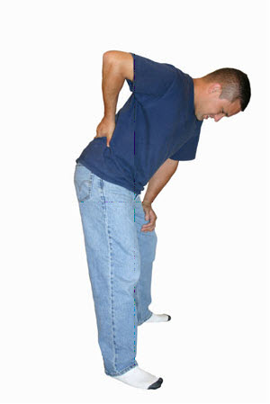
Hello to everyone in [city], [state]. Dr. [last_name] here and I want to help you deal with all of your chiropractic needs, including problems that you have with bad backs. Whether it has happened because of a work injury, a sports injury or because of a genetic or degenerative disorder, your bad back may be keeping you from enjoying your life the way that you would like. If you live in or around the [city] area, come to my office located at [address], [zipcode], so that we can get started on the treatment that will work the best for your bad back. When you are dealing with a bad back, you might find other things affected as well. You may not get as much work done. You may not be able to enjoy sports or hobbies like you used to. You may not even be able to eat or sleep like you normally do. Before you let a bad back destroy your entire life, come see me, Dr. [last_name], at my office at [address], [zipcode], and we can start looking for the right treatment solution for you.Some people who have bad back problems may try using traditional medications or even surgery. They may even try new mattresses or other ideas that may not work very well for them. If the problem persists, it may be time to call my office at [address], [zipcode], for a consultation. Not only will we use careful adjustments, we will teach you exercises that will help you to get back to your regular lifestyle. There is no need for your bad back to keep you from enjoying your life.
Work Injuries
Greetings! Allow me to introduce myself. I am Dr. [last_name],a chiropractor located in [city], [state]. Whether you have a new or old work injury, I can help you. The first step of this process is simple: we need to establish the extent of the problem that you are having and design a plan to make sure that you are restored back to health and fitness. Many of your friends and family in [city] come here to my office at [address], [zipcode], to get the care that they need. Think about a work injury: not only does it affect your performance, not to mention comfort, while on the job, it can also affect your life outside of work as well. A work injury can last for a long time, especially if it is not treated properly and carefully. In fact, if you have a work injury that is not being treated correctly, you can make that injury much worse. I have helped many people in my [city] office, and I can help you to deal with your work injury as well. What people do not understand about chiropractic care is that it is an ongoing process that requires the patient to take part in their own care. Dr. [last_name]'s office will devise an exercise program that will go along with your professional adjustments and treatments. Do not spend another minute dealing with the pain and discomfort of your work injury. My [city] office is open during convenient hours so that I can take care of all your chiropractic needs.
Stiffness and Soreness in Joints Doesn’t Have to Get You Down
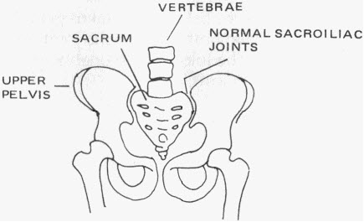
Hello. My name is Dr. [last_name], and I am a chiropractor in [city], [state]. Are you suffering from stiffness and soreness in your joints? Are you tired of taking medications that do not work, are addictive or make you so sleepy that you can’t perform your normal daily tasks? You can ease your pain with chiropractic treatment, and I specialize in treatments that involve stiffness and soreness in the joints. If you are suffering from stiffness and soreness in your joints, you have probably tried all kinds of conventional treatments, including prescription and over-the-counter medications. These can be addictive or have harmful side effects. Often, these medications make you sleepy, and you are unable to function properly. This is no way to live. Instead of relying on drugs, which over time will have less and less effect on your condition, why not give chiropractic a try? There are many ways that chiropractic can help your joint stiffness and soreness. Spinal adjustments and posture correction are two of the techniques that I commonly use. I have been successfully helping patients in [city], [state], with joint soreness and stiffness for many years, and they continue to remain pain-free. I know that I can help treat your pain, so why live with it any longer? If you are suffering from joint pain and stiffness, are tired of taking medication, and do not want to undergo invasive and painful surgery, there is an alternative. Come and see me at my office, which is located at [address], [zipcode], and I will get to work on creating the best course of chiropractic treatment for your condition, and see to it that you live a pain-free life.
Chiropractic Care for Wrist Pain
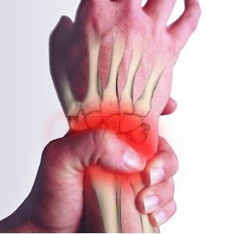
Hi Folks! I am Dr. [last_name], and I am one of the most well-known chiropractors in [city], [state]. For many years, I have been successfully treating patients with wrist pain. If you have been experiencing wrist pain, and have been told that your only options are medications or surgery, come and see me. I can treat your wrist pain, and make sure that you do not have that pain in the future, through a series of chiropractic treatments. There are many reasons for wrist pain, and these days with so many people using computers so much, carpal tunnel is becoming more and more common. I see hundreds of patients every year who are afflicted with carpal tunnel syndrome, and they all report the same thing: they are in extreme amounts of pain, are unable to perform normal, everyday functions and traditional treatments are not working for them. They do not want to have surgery because it involves a lot of pain and time missed from work. So, what is the next option? Chiropractic care! When patients come to see me Dr. [last_name], for their wrist pain, after diagnosing the problem, I embark on a series of treatments. Some of these treatments at [address], [zipcode], may include spinal adjustments and realignment of the extremities. Exercises may be given, which you can also do at home to continue your care and remain pain-free for life, no matter what type of job you do. So, if you are living in [city], [state], and are suffering with the pain caused by carpal tunnel syndrome, come and see me, Dr. [last_name], in [city], to become pain-free.
Arthritic Conditions Could be Helped by a Chiropractor
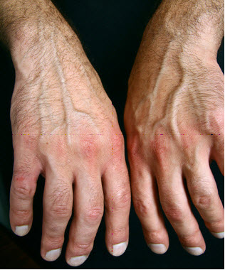
Dear people of [city], [state], my name is Dr. [last_name], and I am a chiropractors in the [city] area. I have successfully treated hundreds of arthritis patients in [city], and I am looking forward to helping you too. Many of my patients from[city], report a variety of symptoms from their arthritic conditions. These symptoms can range from stiffness to pain to swelling to muscle, bone and joint deterioration. These conditions are often life-altering because they can cause patients to lose much of their mobility. I will work with my patients at my office in [address], [zipcode], to get to the root of their pain, and use chiropractic treatments to ease, and in many cases, eliminate that pain. In addition to the treatments I offer in my office at [address], [zipcode], there are many things you can do yourself to help control the pain caused by your arthritic condition. Many arthritic conditions are caused by injuries, so if you are injured in any way, follow your doctor’s orders to ensure that you won’t suffer from arthritis pain once your injury has healed. If you do work that involves heavy lifting, bending, stooping, etc., learn ways to do these jobs that are not as hard on your joints. And see me for treatments. My office is located at [address], [zipcode], and I am always ready to take on new patients.

Upper Back Pain Treatment
Hello. My name is Dr. [last_name], and I am one of the leading chiropractors in [city], [state]. I have been successfully treating patients with upper back pain for many years, and have seen first-hand how chiropractic care can help all kinds of conditions with the joints such as the shoulders, the muscles in the neck, shoulders and back, and the spine. My treatments involve adjustments of the spine, which can correct misalignments and ease or eliminate your pain. Some of the causes of upper back pain include poor posture, injury, whiplash, disc disease and degeneration, large breasts, sprains and strains and even heart disease. These can all cause you to experience extreme pain on a regular basis. The techniques that I use for your treatment in my office at [address], [zipcode] will help to cure the cause of your upper back pain. Although it is not always as severe as lower back pain, upper back pain is just as common, and millions of Americans live with it every day. Upper back pain is not something that needs to be a permanent condition, nor does it always need to be treated with prescription or over-the-counter medications or surgery. In fact, many of my patients report significantly lower levels of pain, if not complete elimination of pain, after undergoing my treatments. If you have been living with upper back pain and traditional treatments have not been helping you, I can help. Come see me, Dr. [last_name], at my office, which is located at [address], [zipcode] for a consultation. I will perform an examination and diagnose your condition, then work on making you feel better.
Chiropractic Care for Asthma Patients
Did you know that according to the Centers for Disease Control (CDC), approximately 20 million Americans suffer from asthma and many of these people do not even realize that they have the condition? Asthma is a condition that can be controlled through medications, but if you do not want to spend your life using inhalers and taking pills, you may want to try an alternative route and go to see a chiropractor. Hello. I am one of the leading chiropractors in [city], [state], and I can help you manage your asthma and the symptoms that go with it. Often, many conditions, including asthma, are caused by a misalignment in the spine, which can pinch nerves and keep them from doing their jobs properly. Through a course of chiropractic treatment at my office in [address], [zipcode], I can correct this misalignment, which will reduce, and possibly even eliminate, your asthma symptoms. One of the ways that I can correct the misalignment is through a spinal adjustment. Studies have shown that this sort of treatment is effective in improving asthma symptoms, and I have successfully treated many asthma patients in [city], who found that traditional treatments just weren’t cutting it for them. Along with my treatments, you can also do things to help yourself, including changing bed linens at least once a week, not having pets in the home (or, if you really love your pets, at least keep them outside as much as possible), dusting regularly and installing an air filter in your home. So, if you are suffering from the symptoms of asthma and want to discover a treatment that works, come and see me, Dr. [last_name].
We Can Effectively Put an End to Mid-Back Pain
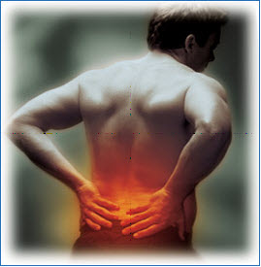
My name is Dr. [last_name] and I want to help you, the folks in and around [city] to deal with your troubling mid-back pain. I am a chiropractor in [city], and I see literally hundreds of patients who have many kinds of mid-back pain on a daily basis. I have seen many of these folks, even those who have been disappointed with traditional treatments and can help them to finally get rid of the pain that is keeping them from living their best life. There are a number of causes of mid-back pain, trust me, and I have seen a number of these cases in [city] involving all of these causes and treated them effectively. Mid-back pain is one of the most common back conditions and can be seen in both male and female patients. Whether your mid-back pain is caused by accidents, poor posture, strain, disc degeneration or abnormalities in the bones or joints that let your back become misaligned, it can be treated. As a chiropractor in [city], I specialize in the treatment of these muscular and skeletal problems, including the vertebrae. I can also help you to learn to effectively manage your pain. You will have scheduled treatments at my office in [city]. I will help you to regain your flexibility so that you do not have to live with pain. You do not have to live with mid-back pain of any kind in [city] any longer. You have other things to do, after all, and should not have to do them with pain and immobility because of mid-back pain. Visit me, Dr. [last_name], at my [city] chiropractic office and get the relief that you need and deserve right away.

